Maxim’s POS Polling Enterprise Service Bus Implementation Service

**EL-FY16-902**

**Sales/Master/Pricing Data Exchange**

SOA Installation Guide

Prepared by: Buzz IT Company Limited

Author: Steven Chen

Date: 13/01/2017

Version: 0.9

# **Document Control**

## **Document History**

| Version | Date | Author | Revision Remark |
| --- | --- | --- | --- |
| 0.1 | 14/03/2017 | Steven Chen | 1st draft |
| 0.2 | 20/03/2017 | Tommy Leung | Update when UAT dpeloyment |

## **Document/Design Owner**

| Name | Title |
| --- | --- |
| Steven Chen | System Analyst |
|  |  |
|  |  |

# **Contents**

**Document Control** 2

**Document History** 2

**Document/Design Owner** 2

**User & User Group** 3

**Create Oracle File System** 3

**Setup Environment variables for oracle user** 4

**Install JDK to /home/oracle/products/** 4

**Install & Setup XWindows Server** 5

**Setup RCU** 6

**Install SOA** 7

**JDeveloper Setup** 16

**Reference Document** 16

# **User & User Group**

/usr/sbin/groupadd -g 501 oinstall

cut -d: -f1 /etc/group

/usr/sbin/useradd -u 502 -g oinstall –G adm,admin oracle

/usr/sbin/useradd -u 502 -g oinstall --groups adm oracle

passwd oracle

# **Create Oracle File System**

Create below file system for Oracle products and applications

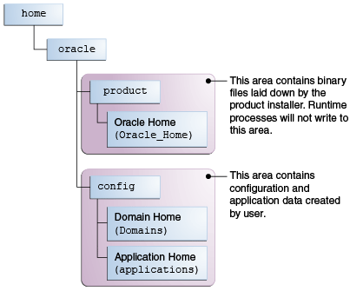

|  |
| --- |
| mkdir -p /home/oracle/products/Oracle_Home  chown oracle:oinstall /home/oracle/products/Oracle_Home  chmod 775 /home/oracle/products/Oracle_Home  mkdir -p /home/oracle/config/domains  chown oracle:oinstall /home/oracle/config/domains  chmod 775 /home/oracle/config/domains  mkdir -p /home/oracle/config/applications  chown oracle:oinstall /home/oracle/config/applications  chmod 775 /home/oracle/config/applications  chown -R oracle:oinstall /home/oracle  chmod -R 775 /home/oracle  mkdir -p /repos/esb/logs/rest  mkdir -p /repos/esb/polling/input  mkdir -p /repos/esb/polling/logs/  mkdir -p /repos/fileUpload/csv  mkdir -p /repos/fileUpload/dbf  mkdir -p /repos/package  mkdir -p /repos/deploy  chown -R oracle:oinstall /repos  chmod -R 775 /repos  mkdir -p /repos/config  upload the server-jdbc.properties  upload the server-key.properties |

# **Setup Environment variables for oracle user**

|  |
| --- |
| vi /home/oracle/.bash_profile  export JAVA_HOME=/home/oracle/products/jdk1.8.0_121  export JRE_HOME=$JAVA_HOME/jre  export CLASSPATH=$JAVA_HOME/lib:$JRE_HOME/lib:WL_HOME%/server/lib:%WL_HOME%/server/liblogic.jar  export WLS_HOME=/home/oracle/products/wlserver  export ORACLE_HOME=/home/oracle/products/Oracle_Home  export DOMAIN_HOME=/home/oracle/config/domains  export WL_HOME=$ORACLE_HOME/wlserver  export PATH=$WL_HOME/server/bin:$JAVA_HOME/bin:$JRE_HOME/bin:$HOME/bin:$PATH |

**UAT**

|  |
| --- |
| vi /home/oracle/.bash_profile  export JAVA_HOME=/home/oracle/products/jdk1.8.0_121  export JRE_HOME=$JAVA_HOME/jre  export CLASSPATH=$JAVA_HOME/lib:$JRE_HOME/lib:WL_HOME%/server/lib:%WL_HOME%/server/liblogic.jar  export WLS_HOME=/home/oracle/products/wlserver  export ORACLE_HOME=/home/oracle/products/Oracle_Home  export DOMAIN_HOME=/home/oracle/config/domains  export WL_HOME=$ORACLE_HOME/wlserver  export PATH=$WL_HOME/server/bin:$JAVA_HOME/bin:$JRE_HOME/bin:$HOME/bin:$PATH |

Edit: /etc/resolv.conf

nameserver 10.20.200.103

nameserver 10.10.1.100

nameserver 10.10.20.20

nameserver 10.10.20.20

search maxims.com

Edit: /etc/hosts

s

Edit: /etc/hosts

10.10.33.26 HKGESBAPPU01

10.10.33.27 HKGESBAPPU02

10.10.33.28 HKGESBAPPP01

10.10.33.29 HKGESBAPPP02

Edit /etc/sysconfig/network-scripts/ifcfg-eth0

DNS1=10.10.20.20

DOMAIN=maxims.com

Edit /etc/security/limits.conf

Add follow entry :

@oinstall soft nproc 10240

@oinstall soft nproc 10240

@oinstall soft core unlimited

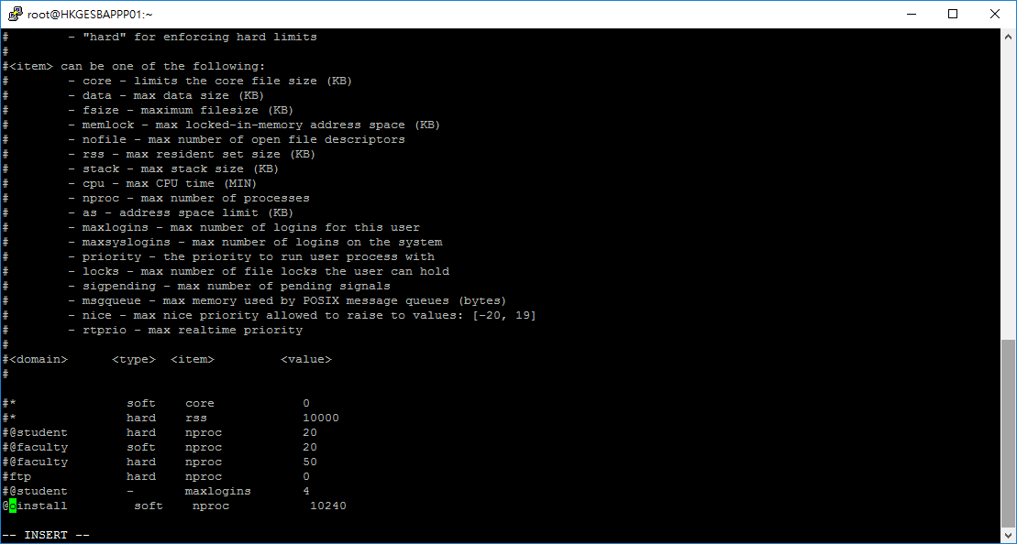

# **Install JDK to /home/oracle/products/**

c:\progra~1\putty\psftp"

open 10.10.33.27

Upload: \document\07 Deployment\software package

\jdk-8u121-linux-x64.tar.gz

To /home/oracle/products/

User: oracle

put jdk-8u101-linux-x64.tar.gz

put fmw_12.2.1.2.0_soa_quickstart.jar

put fmw_12.2.1.2.0_soa_quickstart2.jar

chmod 775 jdk-8u101-linux-x64.tar.gz

chmod 775 fmw_12.2.1.2.0_soa_quickstart.jar

chmod 775 fmw_12.2.1.2.0_soa_quickstart2.jar

tar -xvf /home/oracle/products/jdk-8u101-linux-x64.tar.gz

|  |
| --- |
| chmod 775 jdk-8u101-linux-x64.tar.gz  tar -xvf /home/oracle/products/jdk-8u101-linux-x64.tar.gz  tar -xvf /home/oracle/products/jdk-8u121-linux-x64.tar.gz |

# **Install & Setup XWindows Server**

1. Install Xming in local PC

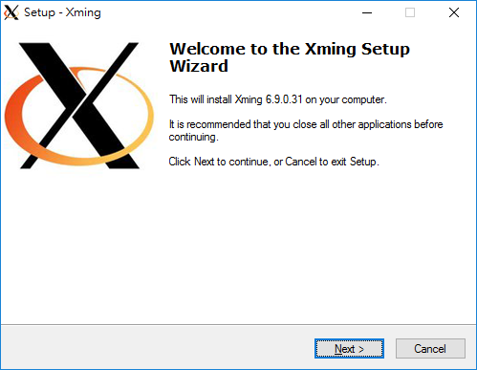

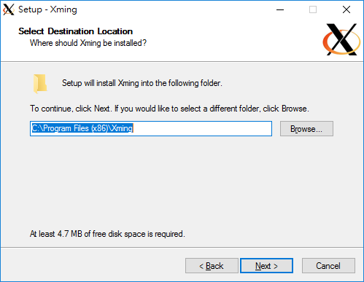

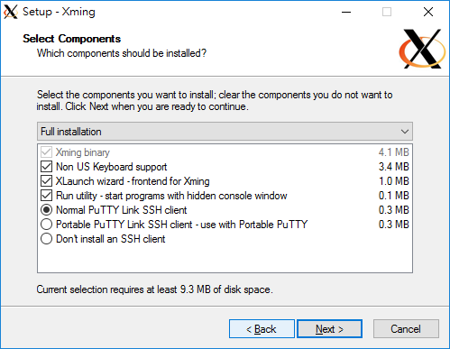

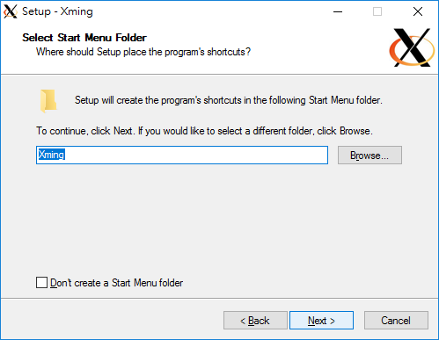

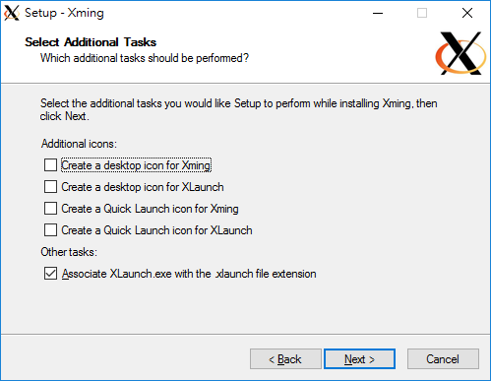

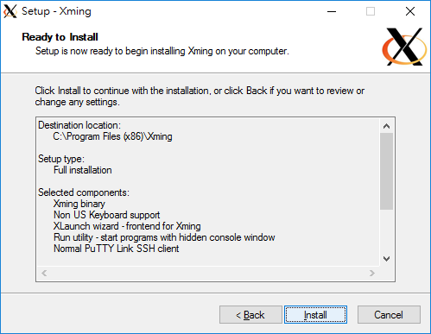

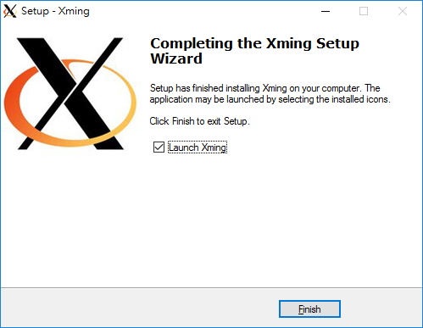

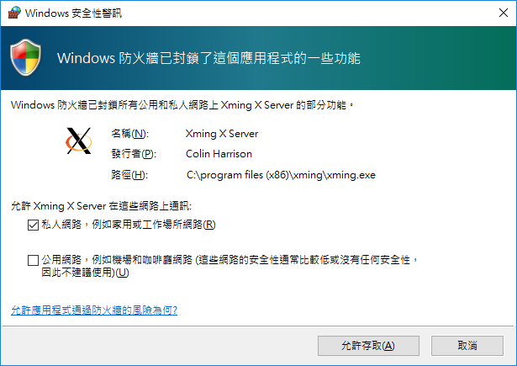

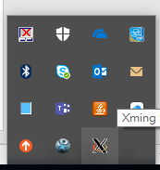

1. Check parameter “X11Forwarding Yes” exists in target host’s /etc/ssh/sshd_config

(root)

cat /etc/ssh/sshd_config | grep 'X11Forwarding'



1. Configure putty X11 configuration

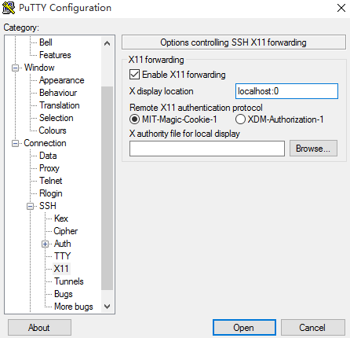

localhost:0

1. export DISPLAY=your.intranet.ip.address:0.0

export DISPLAY=10.20.30.100:0.0

1. Now XWindows Server is ready to connect

cd $ORACLE_HOME/jdeveloper/jdev/bin

./jdev

Add the IP to X0.hosts in c:\program files (x86)\Xming

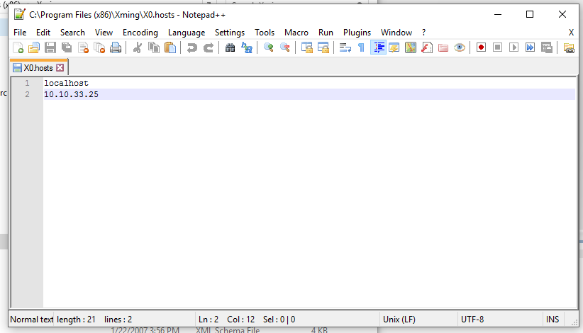

# **Install SOA**

Configure putty X11 configuration

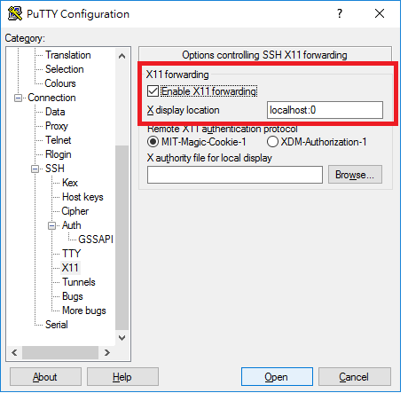

Enable the X11 Forward

Location: localhost:0

document\07 Deployment\software package

fmw_12.2.1.2.0_soa_quickstart.jar

fmw_12.2.1.2.0_soa_quickstart2.jar

To /home/oracle/products/

User: oracle

chmod 755 fmw_12.2.1.2.0_soa_quickstart.jar

chmod 755 fmw_12.2.1.2.0_soa_quickstart2.jar

export DISPLAY=10.20.30.100:0.0

upload lib64wbclient0-3.5.14-1pclos2012.x86_64.rpm

Mount cdrom (root)

cd /media

mkdir cdrom

mount -t iso9660 /dev/scd0 /media/cdrom

cd /media/cdrom/Packages

rpm -ivh libX11-common-1.6.3-2.el6.noarch.rpm

rpm -ivh libXau-1.0.6-4.el6.x86_64.rpm

rpm -ivh libxcb-1.11-2.el6.x86_64.rpm

rpm -ivh libX11-1.6.3-2.el6.x86_64.rpm

rpm -ivh libXext-1.3.3-1.el6.x86_64.rpm

rpm -ivh libXrender-0.9.8-2.1.el6.x86_64.rpm

rpm -ivh libXi-1.7.4-1.el6.x86_64.rpm

rpm -ivh libXtst-1.2.2-2.1.el6.x86_64.rpm

/*****

rpm -ivh libtalloc-2.1.5-1.el6_7.x86_64.rpm

rpm -ivh keyutils-1.4-5.0.1.el6.x86_64.rpm

rpm -ivh lib64wbclient0-3.5.14-1pclos2012.x86_64.rpm

rpm -ivh cifs-utils-4.8.1-20.el6.x86_64.rpm

(try) rpm -ivh samba4-client-4.2.10-6.el6_7.x86_64.rpm

*****/

smbfs

mount -t cifs -o username=poll,password=poll12345,sec=ntlm //10.10.20.214/exports /mnt/exports

mount -t cifs -o credentials=/repos/config/dbf-share.credentials,iocharset=utf8,sec=ntlm //10.20.30.166/export /mnt/esb/dbf

mount -t cifs -o username=poll,password=poll12345,iocharset=utf8,sec=ntlm //10.20.30.166/export /mnt/esb/dbf

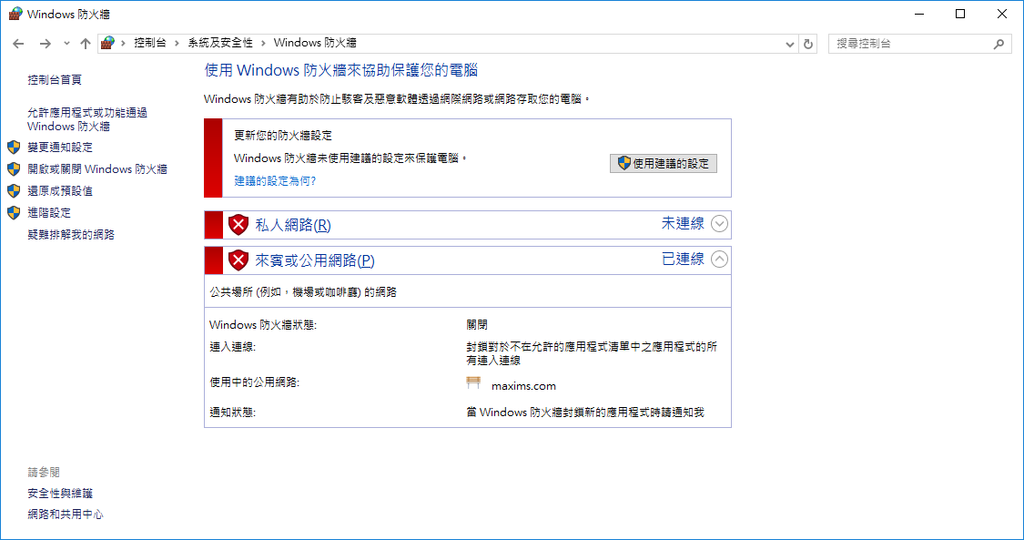

Login as oracle user

Start Oracle SOA Suite Quick Start Installer

|  |
| --- |
| java -jar fmw_12.2.1.2.0_soa_quickstart_generic.jar |

export DISPLAY=10.20.30.100:0.0

/home/oracle/products/jdk1.8.0_101/bin/java -jar /home/oracle/products/fmw_12.2.1.2.0_soa_quickstart.jar

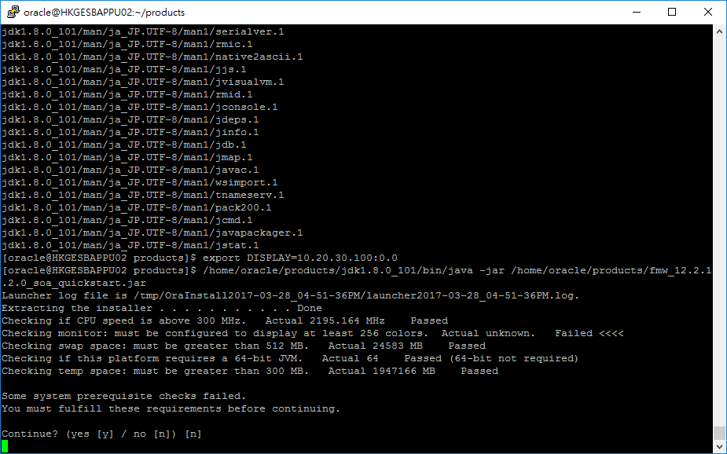

Press Y

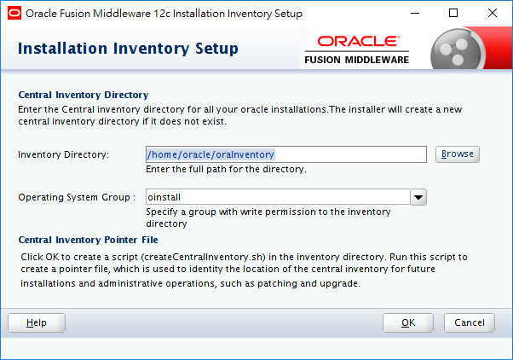

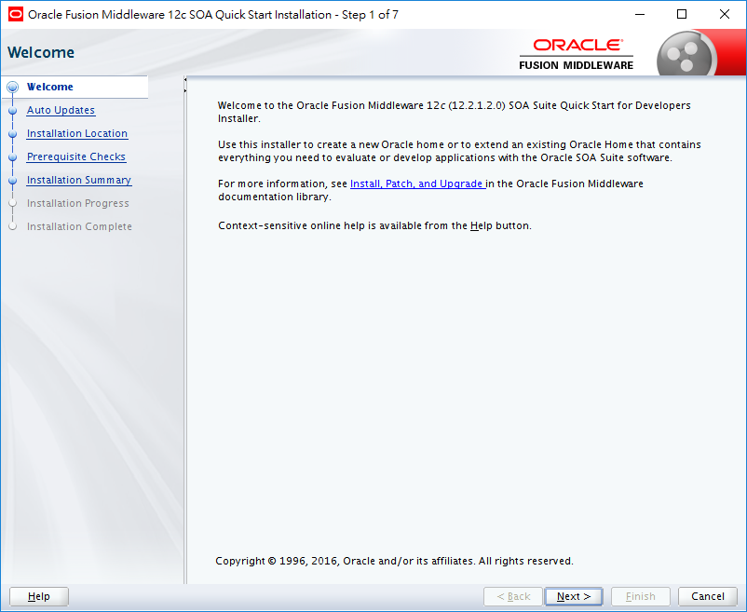 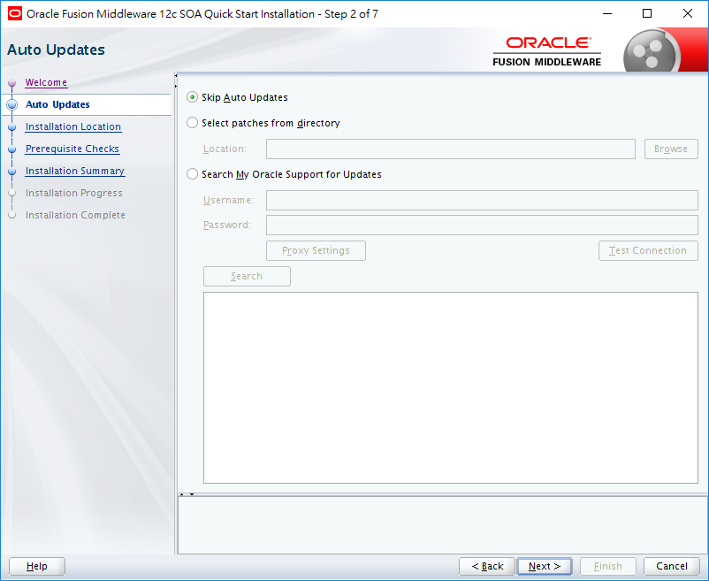

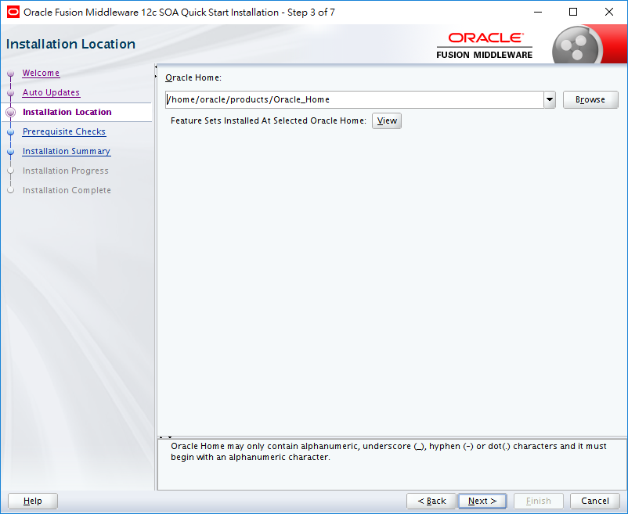

/home/oracle/products/Oracle_Home

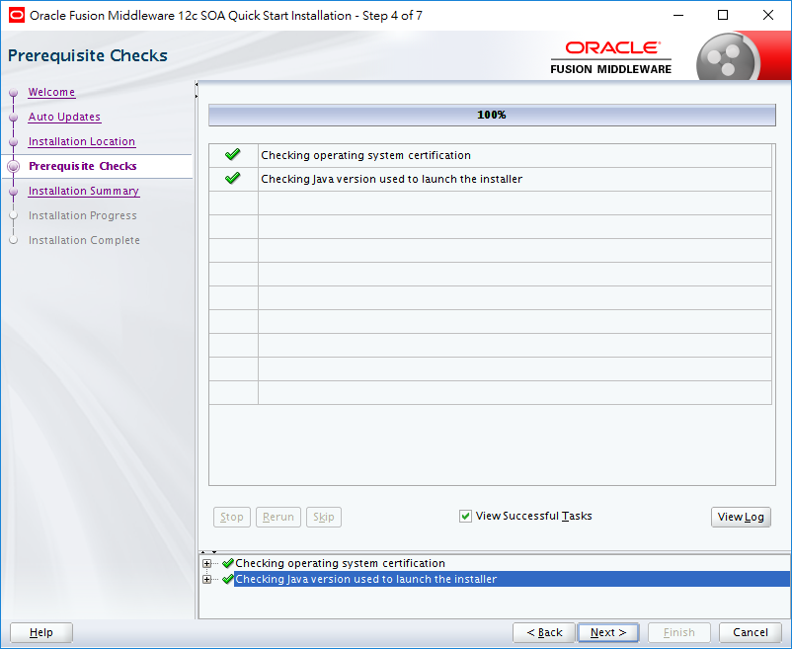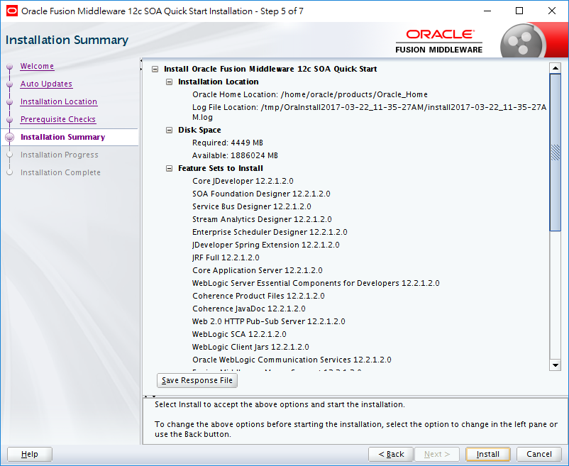

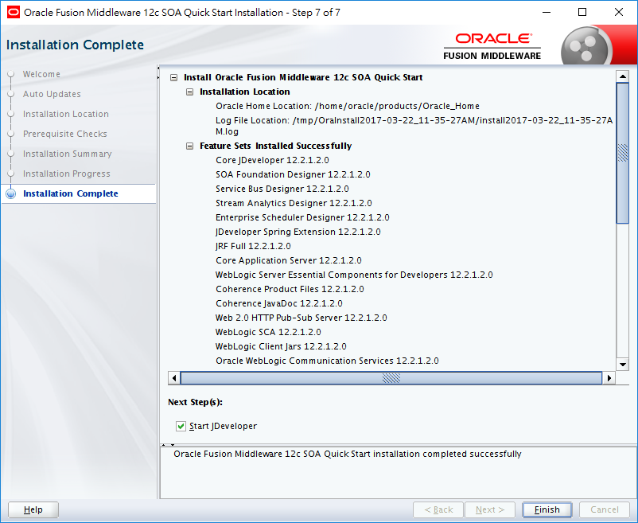

# **Setup RCU**

Create a new Oracle Database for repository.

show parameters nls_length_semantics

--ALTER SYSTEM SET NLS_LENGTH_SEMANTICS=BYTE

export DISPLAY=10.20.30.100:0.0

|  |
| --- |
| **Start RCU**  cd $ORACLE_HOME/oracle_common/bin  Check with Oracle Database installation  ./rcu |

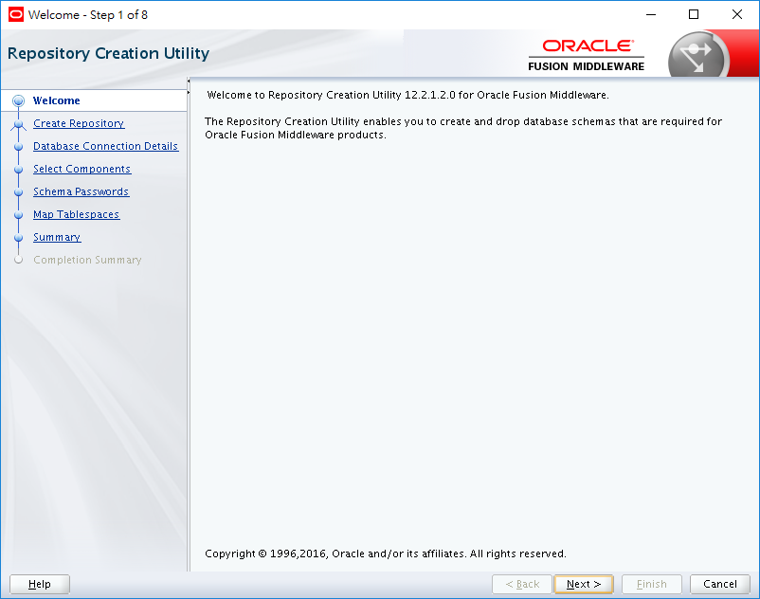

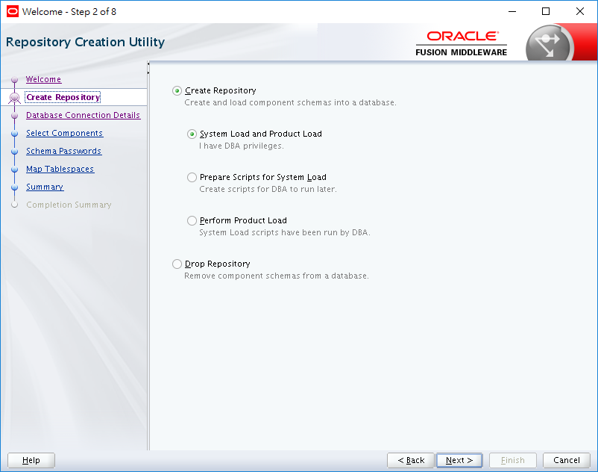

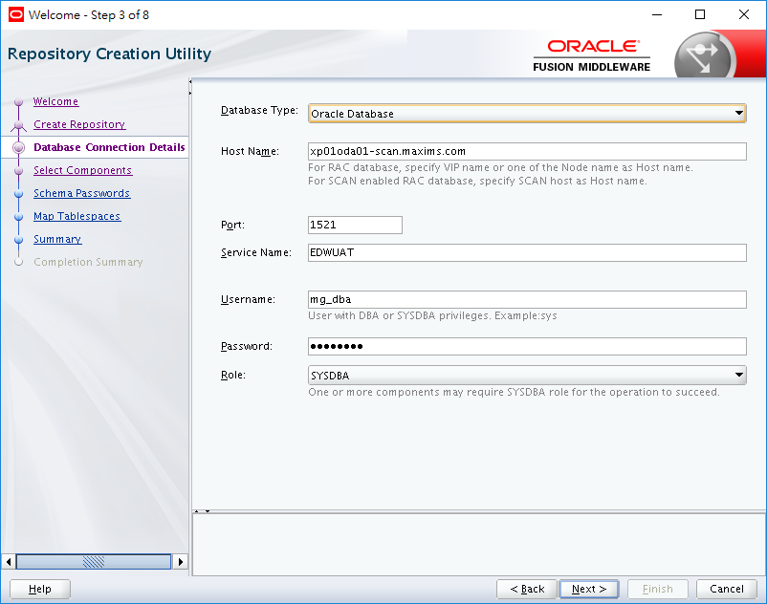

Host: xp01oda01-scan.maxims.com

Port: 1521

Service Name: OSBUAT

Username: mg_dba (provided by Maxim)

(SYSBDA)

Check connection Privilege

And SYSDBA role of user.

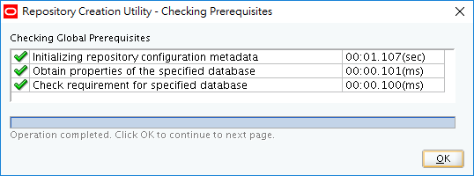

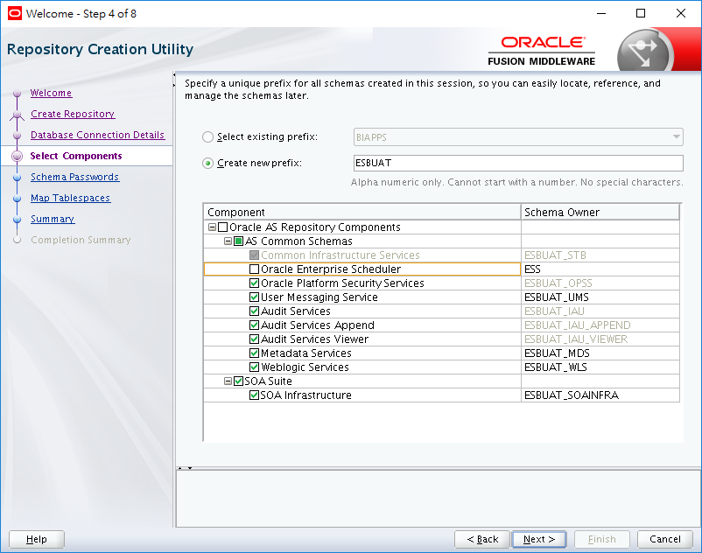

ESBUAT

Select all except ESS

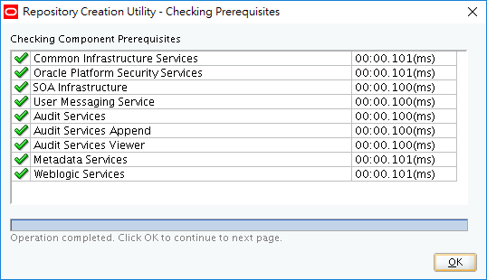

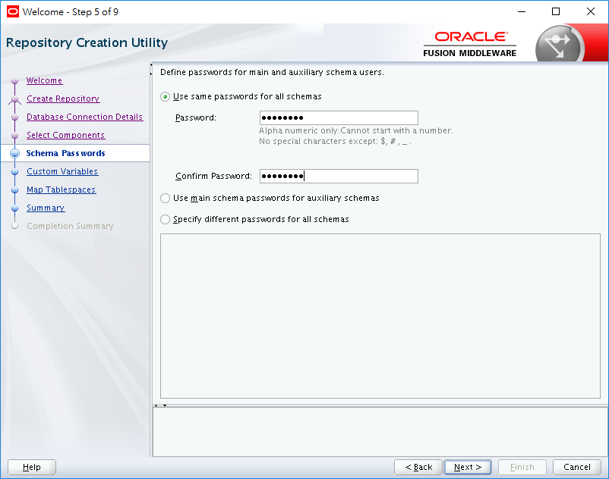

Passowrd : Passw0rd

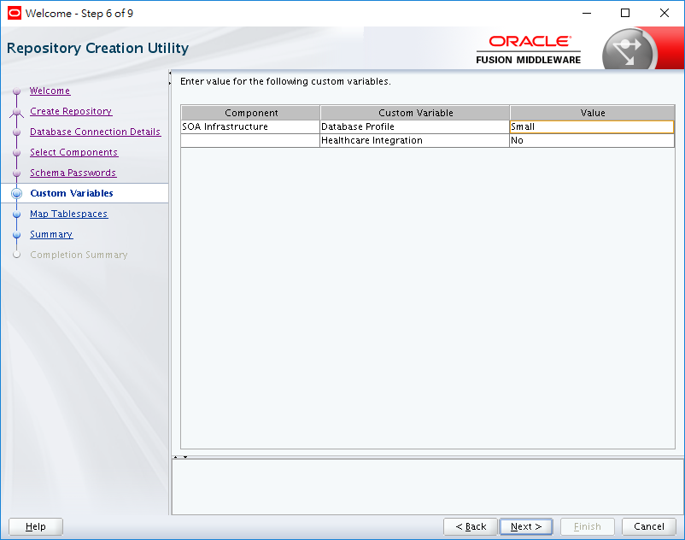

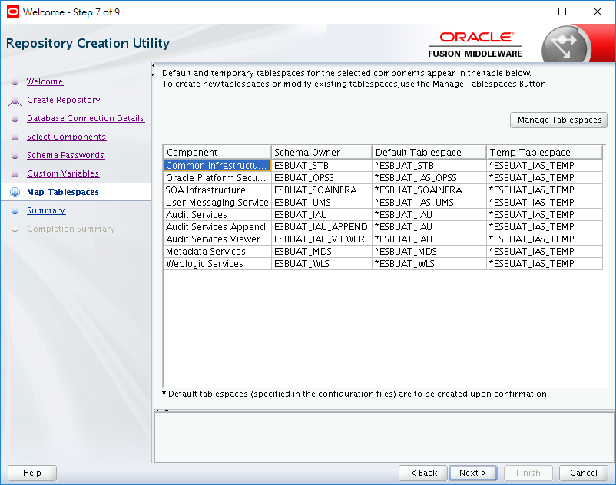

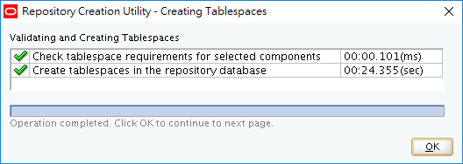

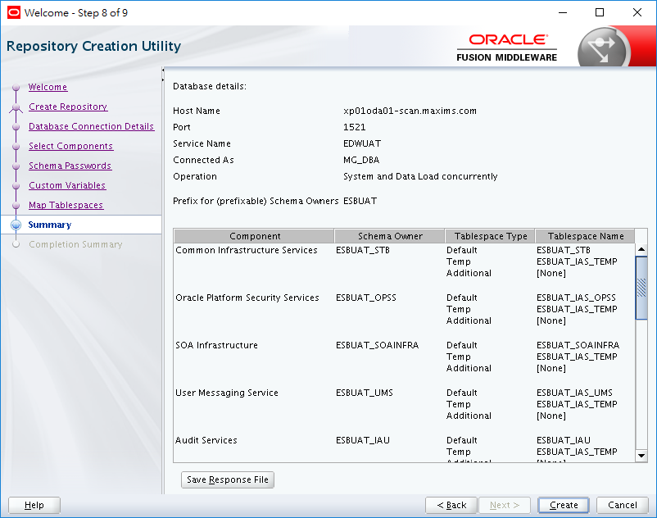

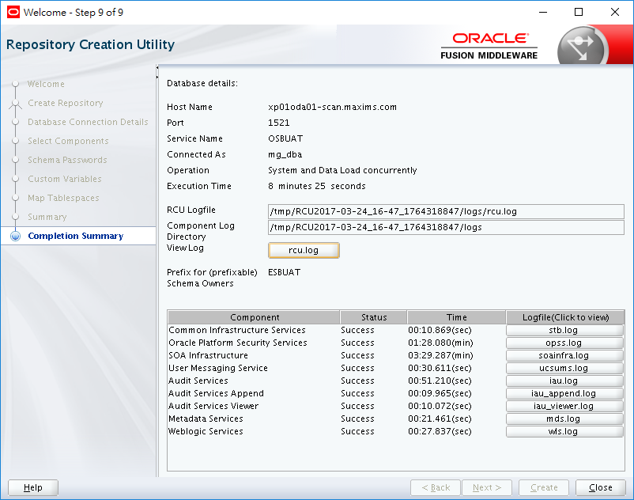

|  |
| --- |
| **For MS SQL Server ONLY**  ALTER DATABASE esb_dev SET READ_COMMITTED_SNAPSHOT ON  with rollback immediate; |

|  |
| --- |
| **Add component command line sample**  ./rcu -silent -createRepository -databaseType SQLSERVER -connectString 192.168.1.250:1433:esb_dev -dbUser sa -dbRole sysadmin -unicodeSupport Yes -schemaPrefix ESB -component SOAINFRA -component UMS |

|  |
| --- |
| **RCU Manual**  <https://docs.oracle.com/cd/E16764_01/doc.1111/e14259/rcu.htm> |

|  |
| --- |
| **RCU Reset Procedure (Delete Schema and Namespaces)**   1. drop user ×× cascade 2. DROP TABLESPACE tablespace_name INCLUDING CONTENTS AND DATAFILES; 3. select comp_name from SCHEMA_VERSION_REGISTRY; 4. delete from SCHEMA_VERSION_REGISTRY where COMP_NAME like 'WebLogic Services'; |

export DISPLAY=10.20.30.100:0.0

|  |
| --- |
| **Create a Compact Domain**  cd $ORACLE_HOME/oracle_common/common/bin  CONFIG_JVM_ARGS="-Dcom.oracle.cie.config.showProfile=true"  export CONFIG_JVM_ARGS  ./config.sh |

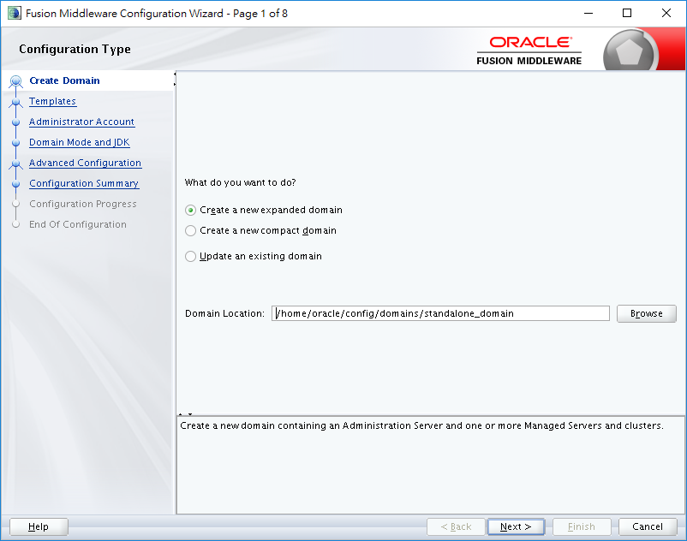

/home/oracle/config/domains/standalone_domain

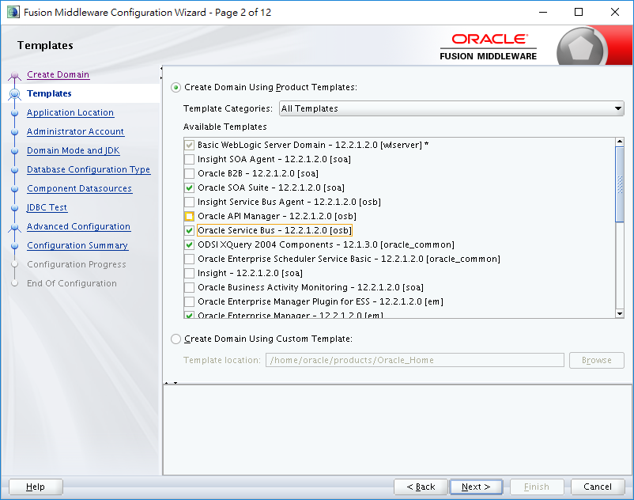c

Check: Oracle SOA suite and Oracle Service Bus

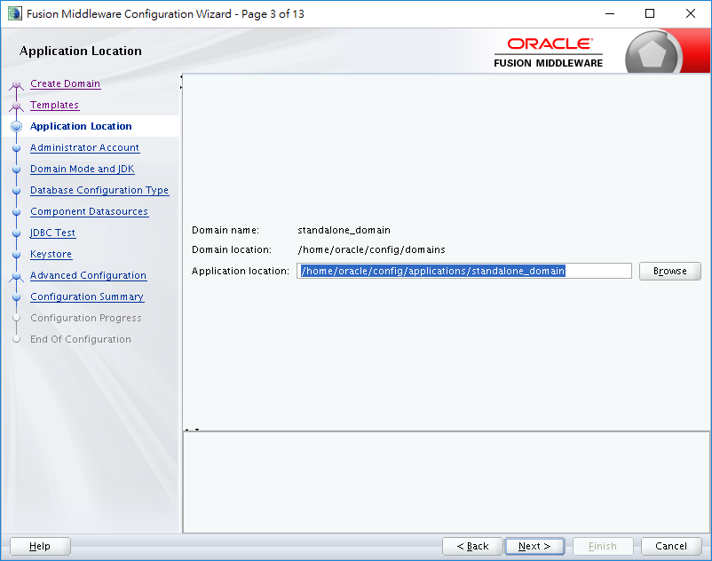

/home/oracle/config/applications/standalone_domain

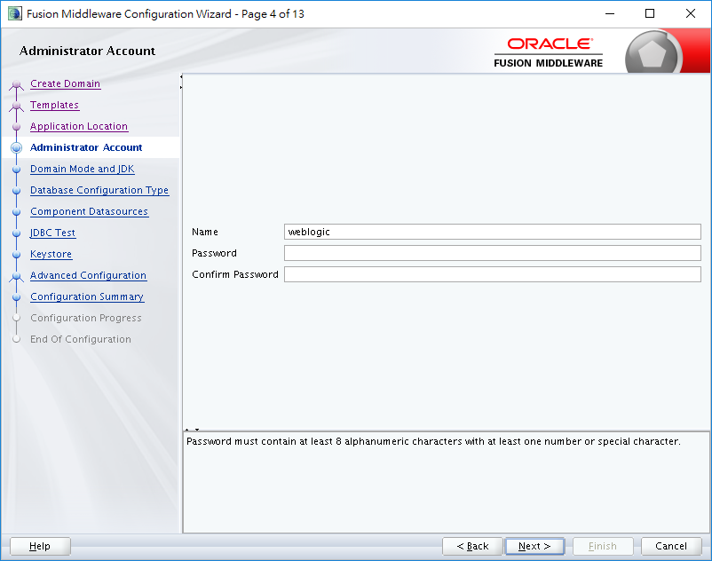

Name weblogic

Password Passw0rd

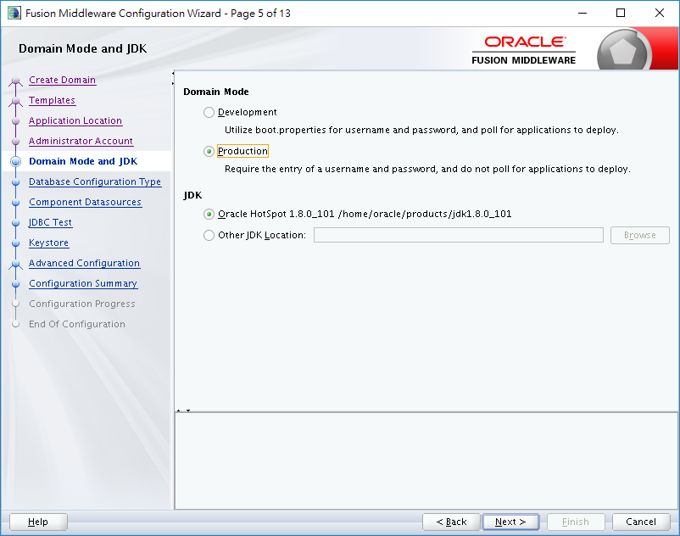

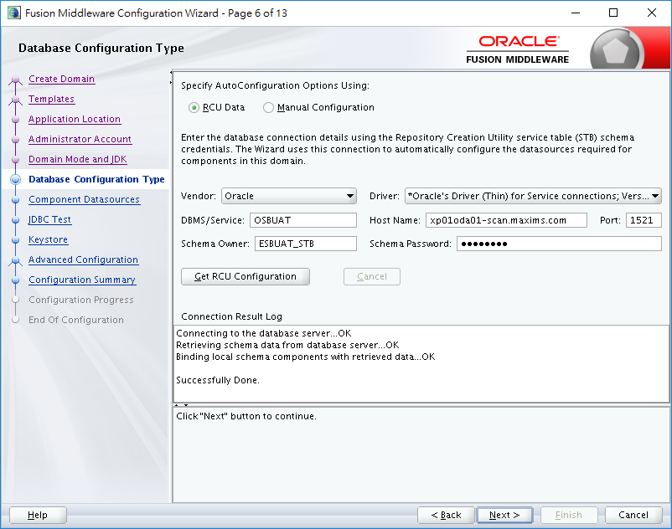

Host: xp01oda01-scan.maxims.com

Port: 1521

Service Name: OSBUAT

Username: ESBUAT_STB

Password: Passw0rd

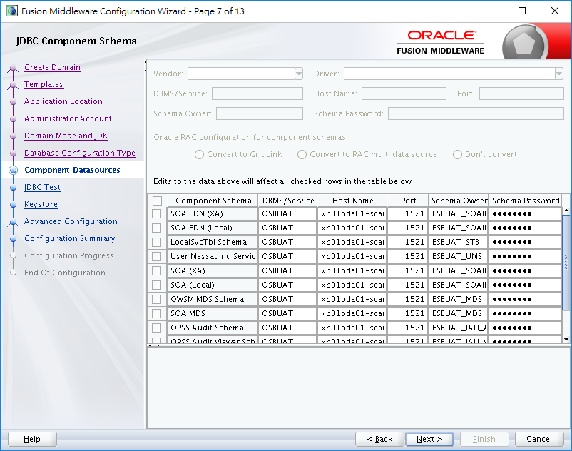

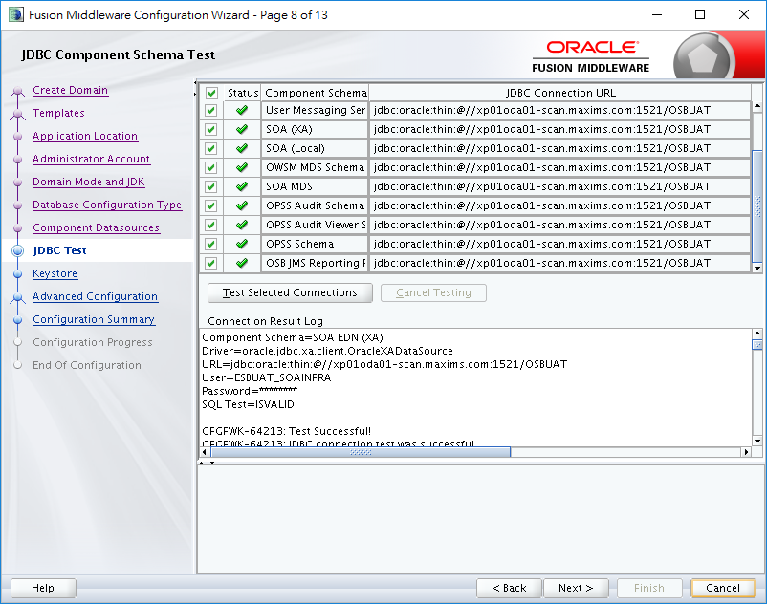

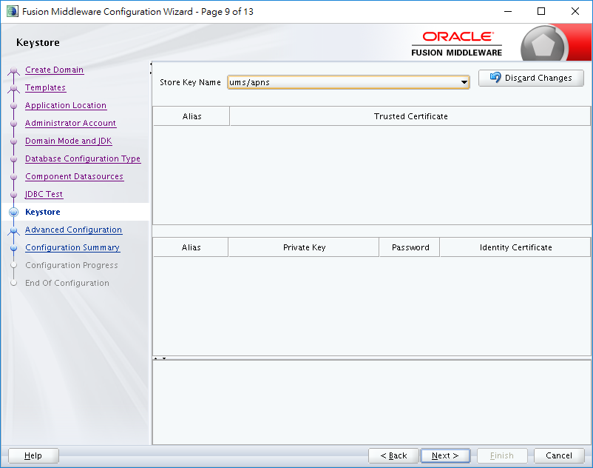

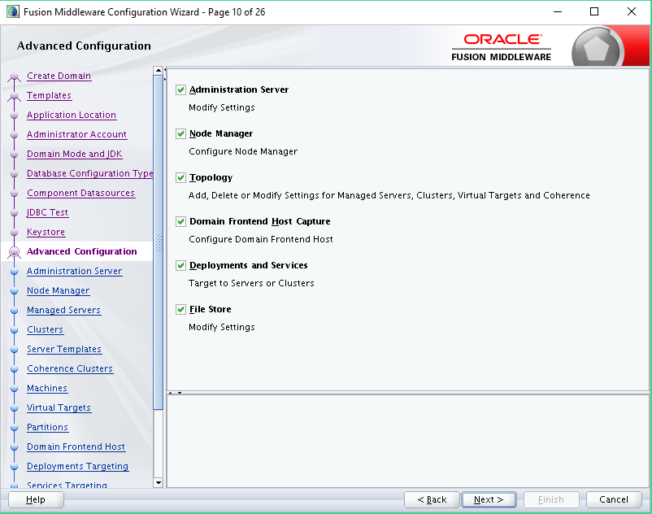

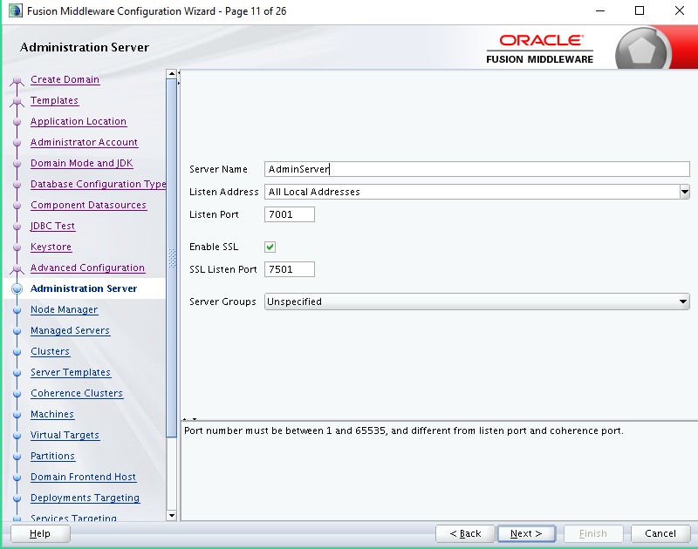

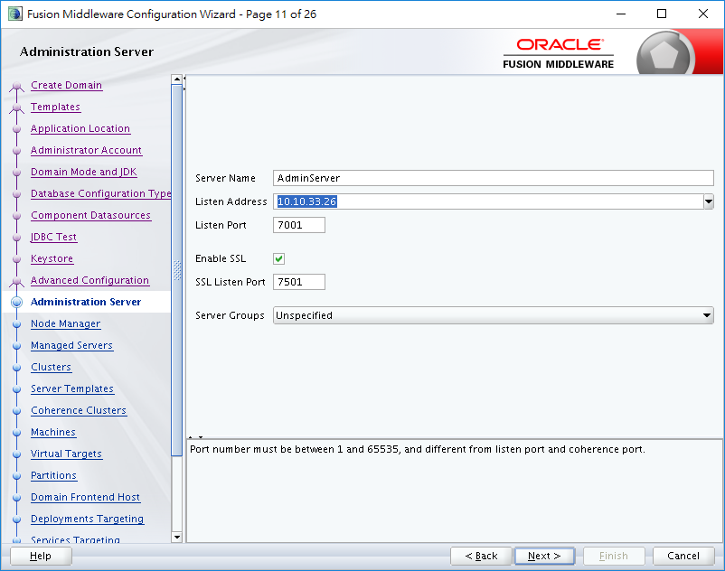

Listen Address -> 10.10.33.26

Enable SSL

Set SSL Port -> 7501

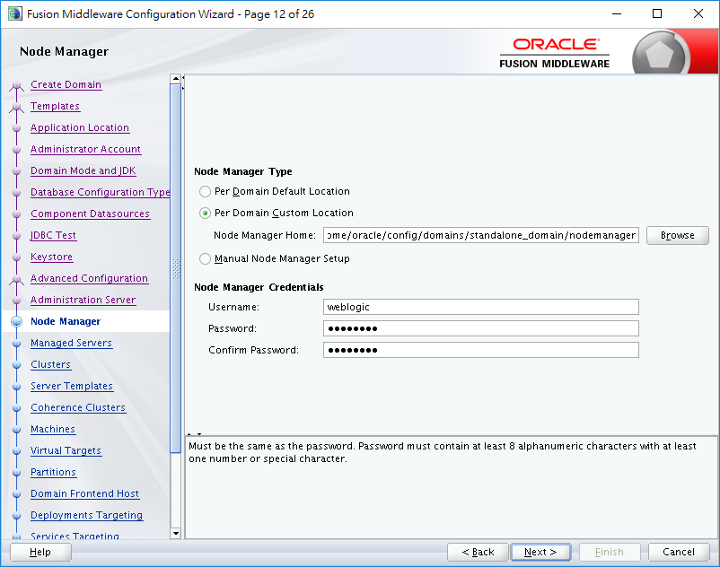

/home/oracle/config/domains/standalone_domain/nodemanager

Username weblogic

Password: Passw0rd

(Below is fault)

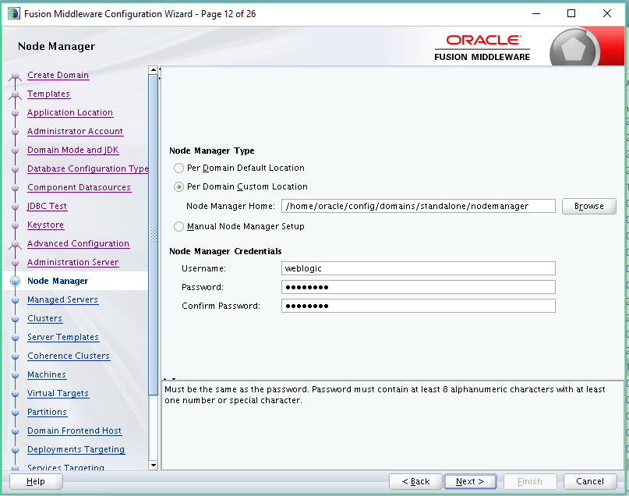

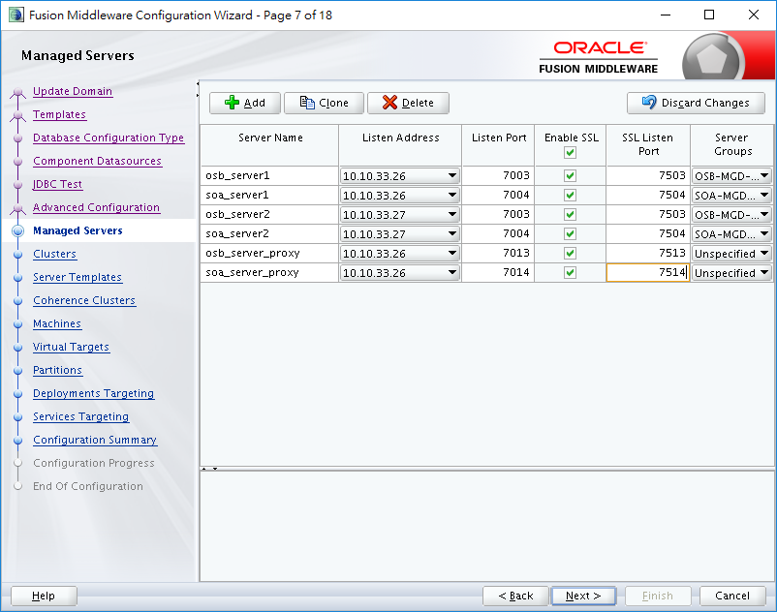

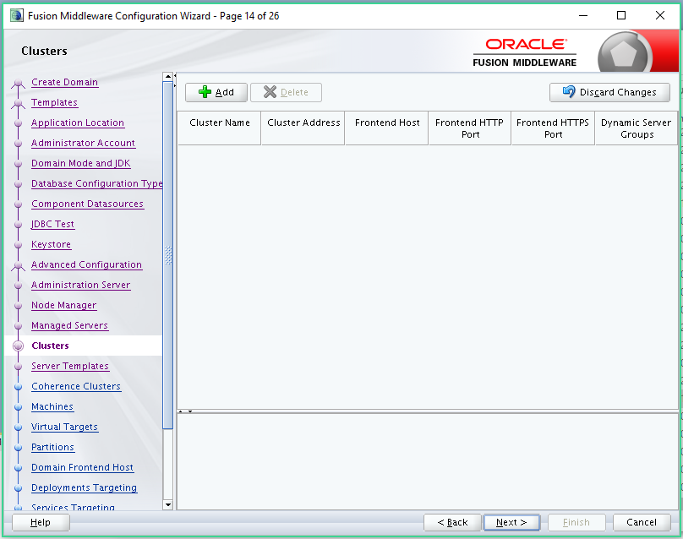

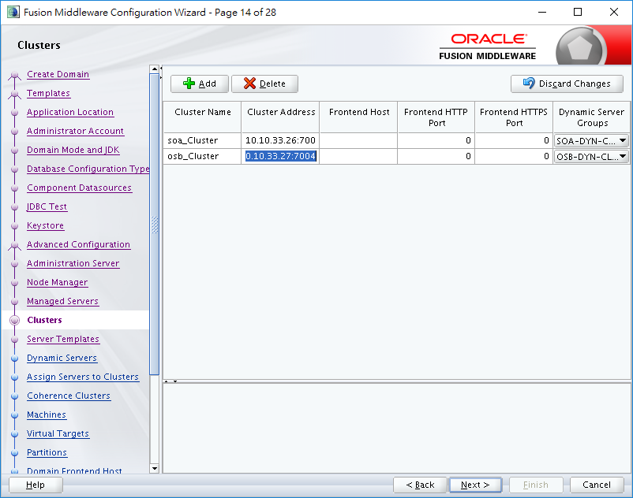

soa_cluster 10.10.33.26:7004,10.10.33.27:7004 SOA-DYN-CLUSTER

osb_cluster 10.10.33.26:7003,10.10.33.27:7003 OSB-DYN-CLUSTER

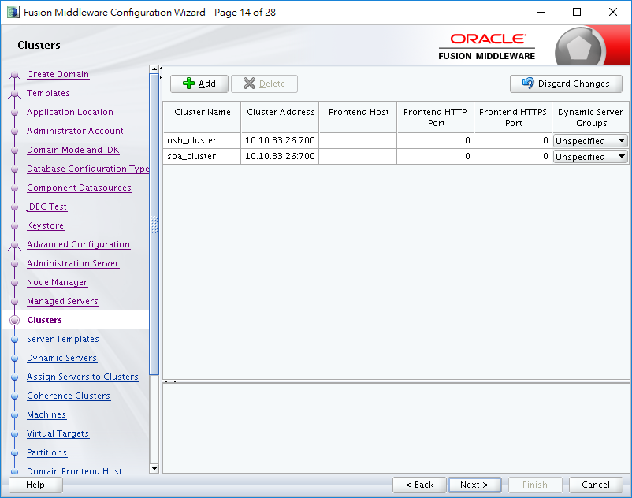

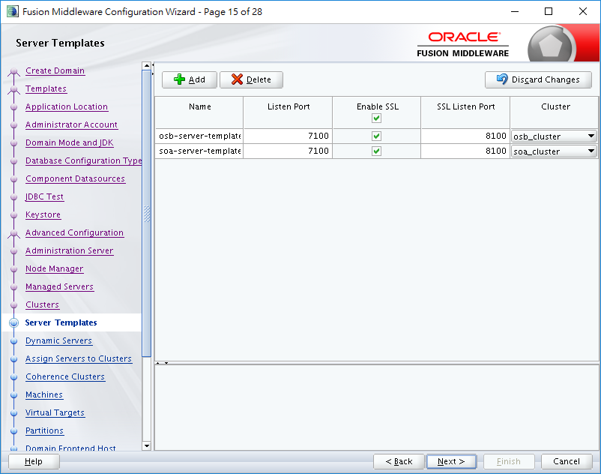

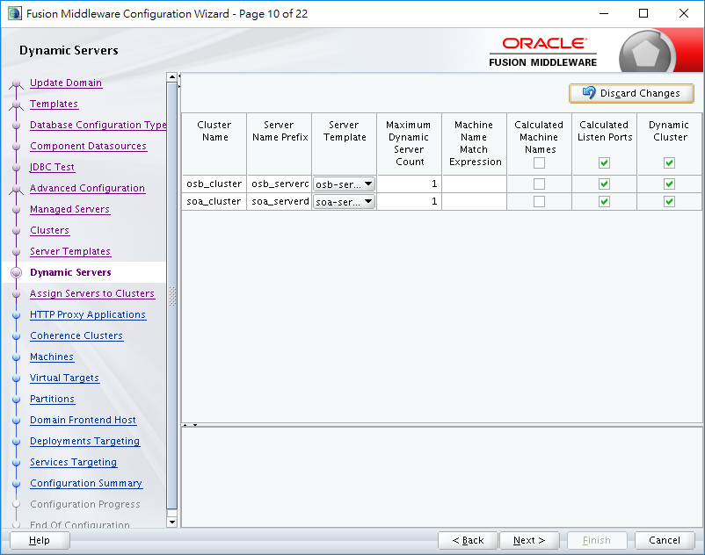

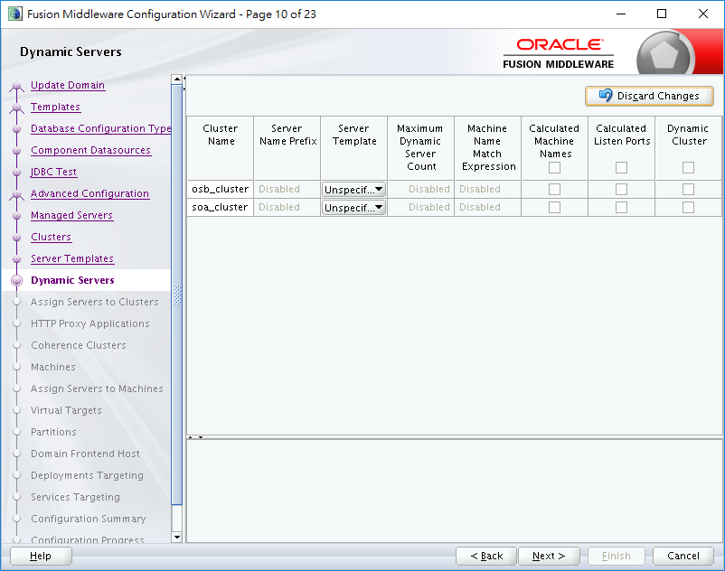

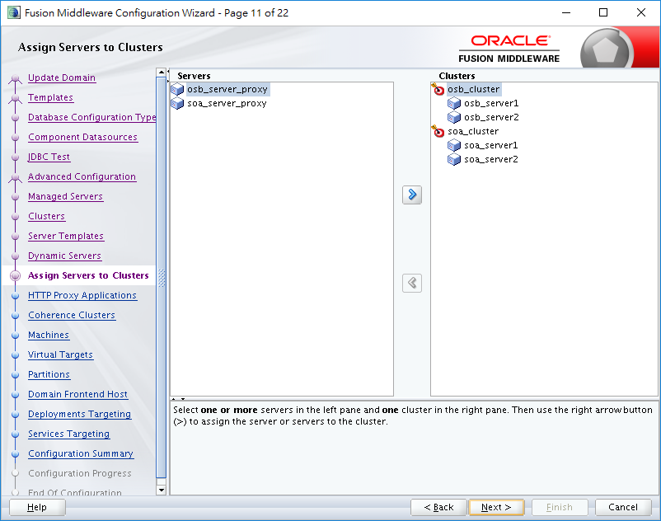

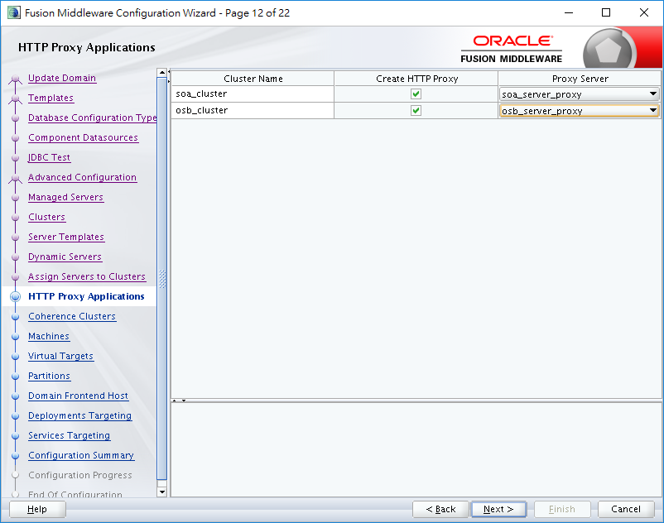

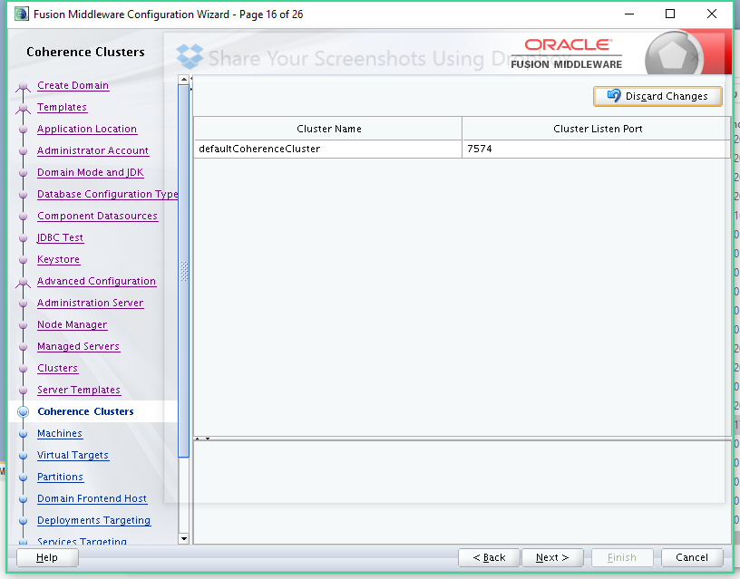

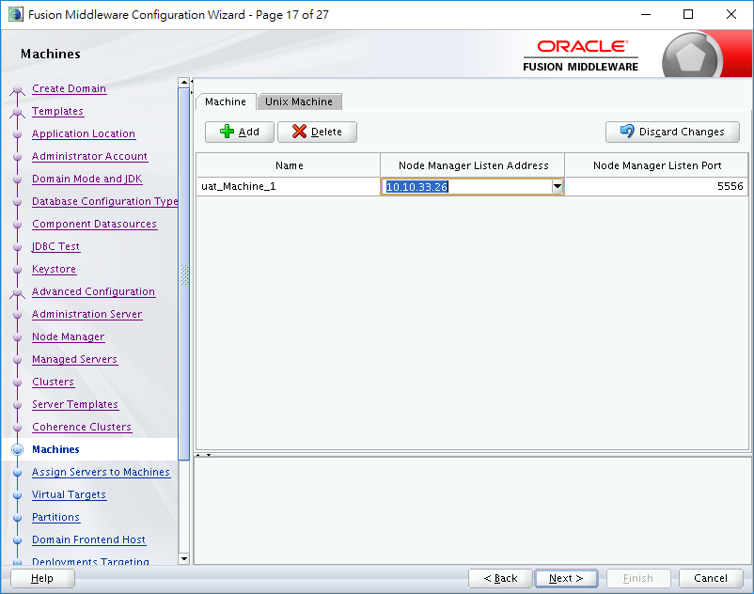

uat_machine_1

uat_machine_2

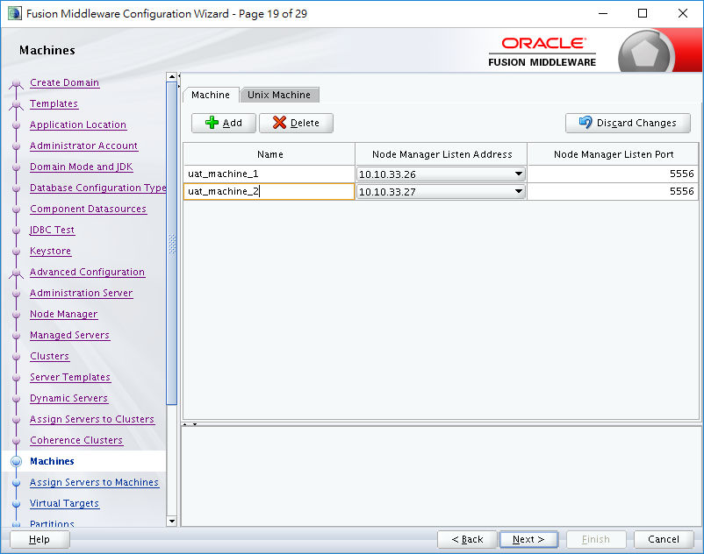

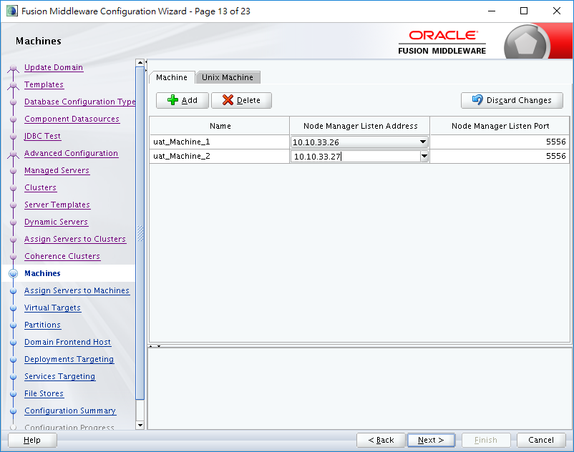

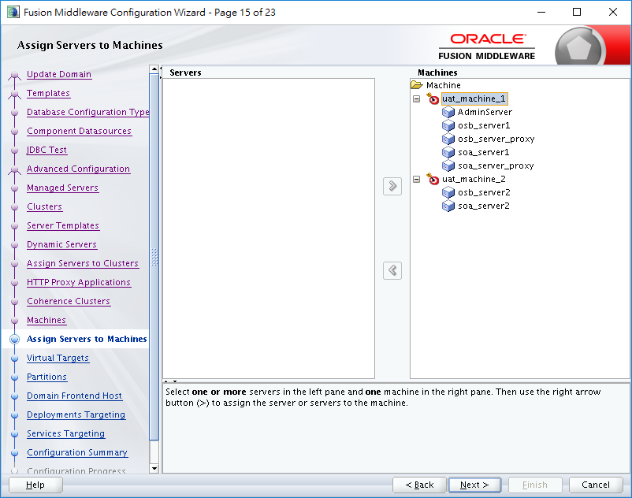

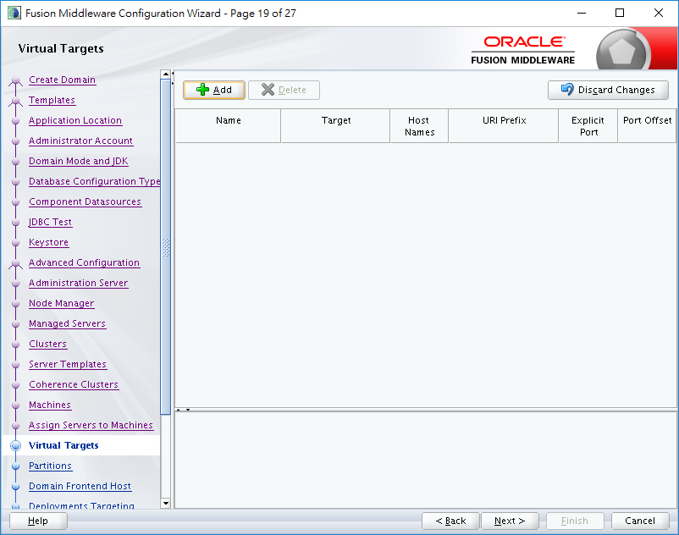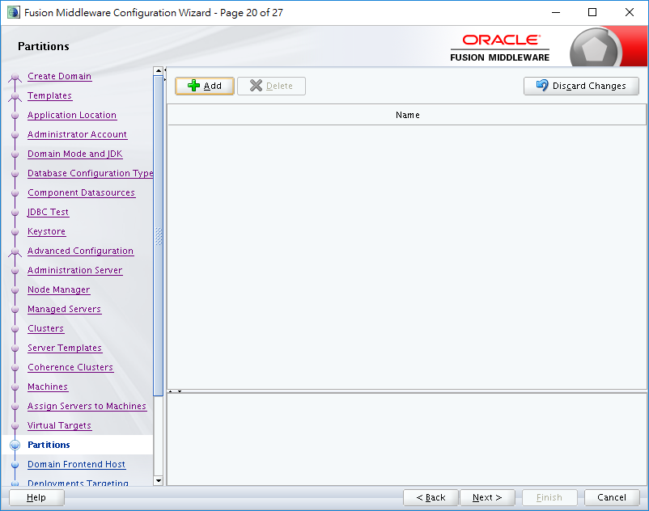

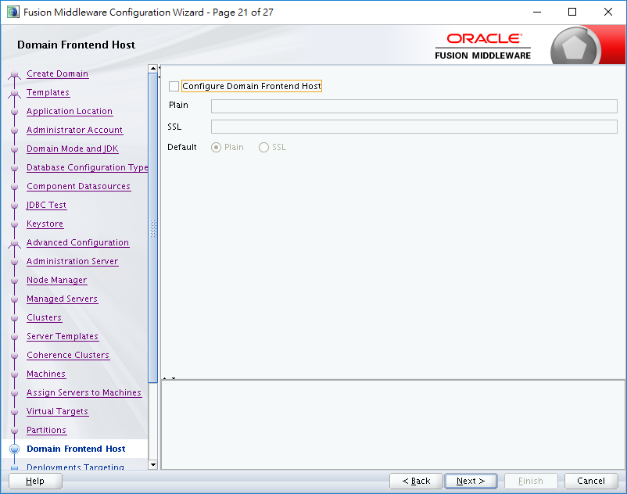

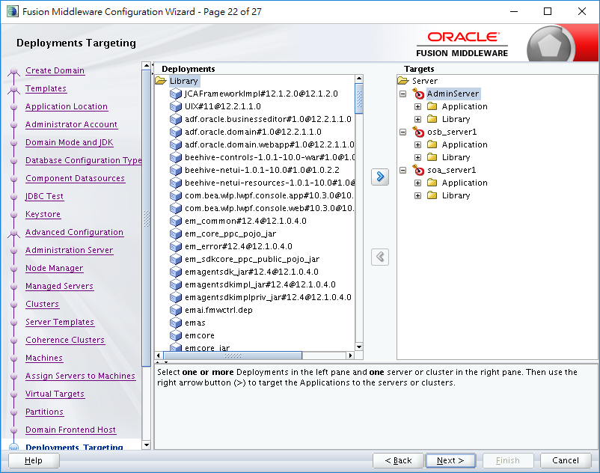

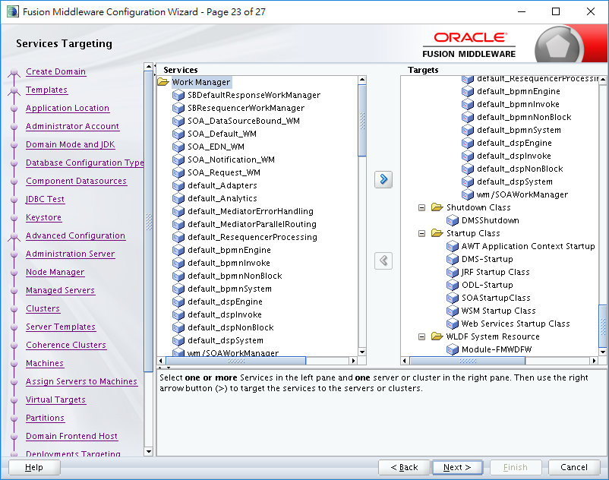

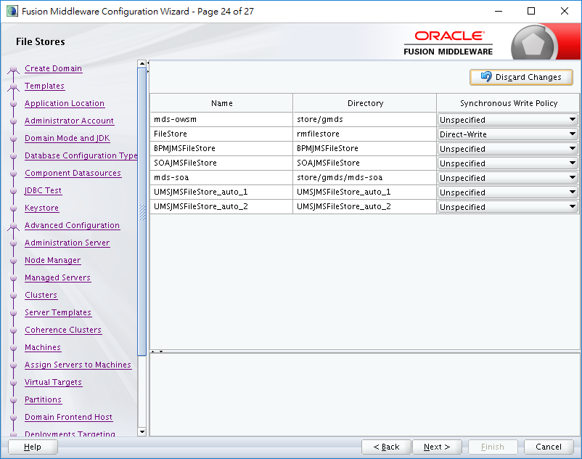

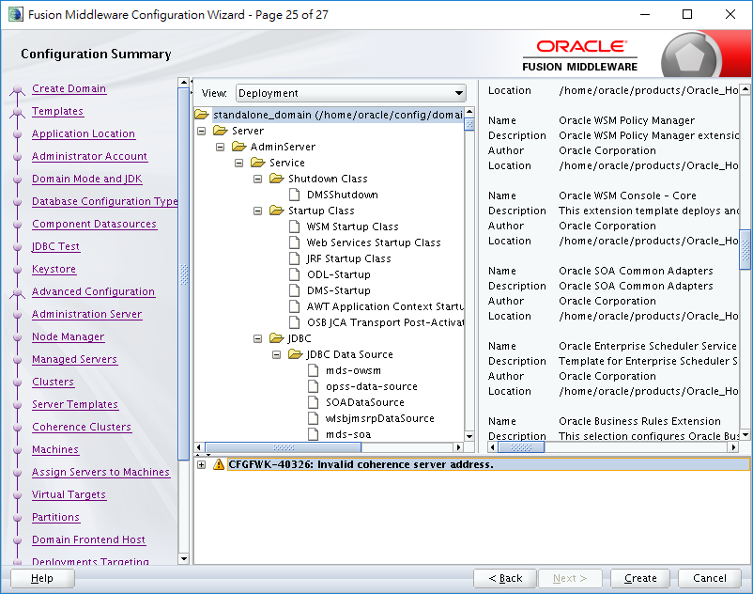

Set Machine 2

cd /home/oracle/products/Oracle_Home/oracle_common/common/bin

./pack.sh -managed=true -domain=/home/oracle/config/domains/standalone_domain -template=/home/oracle/standalone_domain.jar -template_name="standalone_domain"

Upload the jar to machine 2

"c:\progra~1\putty\psftp" oracle@10.10.33.26 -pw Passw0rd

cd /home/oracle

get standalone_domain.jar

"c:\progra~1\putty\psftp" oracle@10.10.33.27 -pw Passw0rd

cd /home/oracle

machine2

cd /home/oracle/products/Oracle_Home/oracle_common/common/bin

./unpack.sh -domain=/home/oracle/config/domains/standalone_domain -template=/home/oracle/standalone_domain.jar

./unpack.sh -domain=/home/oracle/config/domains/base_domain -template=/home/oracle/base_domain.jar

# **JDeveloper Setup**

**Set JDEV_USER_DIR**

(Default) $HOME/jdeveloper/mywork

(Recommended) $HOME/jdeveloper/osb.

|  |
| --- |
| cd $ORACLE_HOME/jdeveloper/jdev/bin  ./jdev  cat /proc/sys/kernel/random/entropy_avail  rngd -r /dev/urandom -o /dev/random -b  EXTRAOPTIONS="-i -r /dev/urandom -o /dev/random -b -t 60 -W 2048"  cd $ORACLE_HOME/jdeveloper/jdev/bin  ./jdev |

# **Appendix**



# **Reference Document**

<https://docs.oracle.com/middleware/1213/core/SOAQS/integrated.htm#SOAQS208>

Error done:

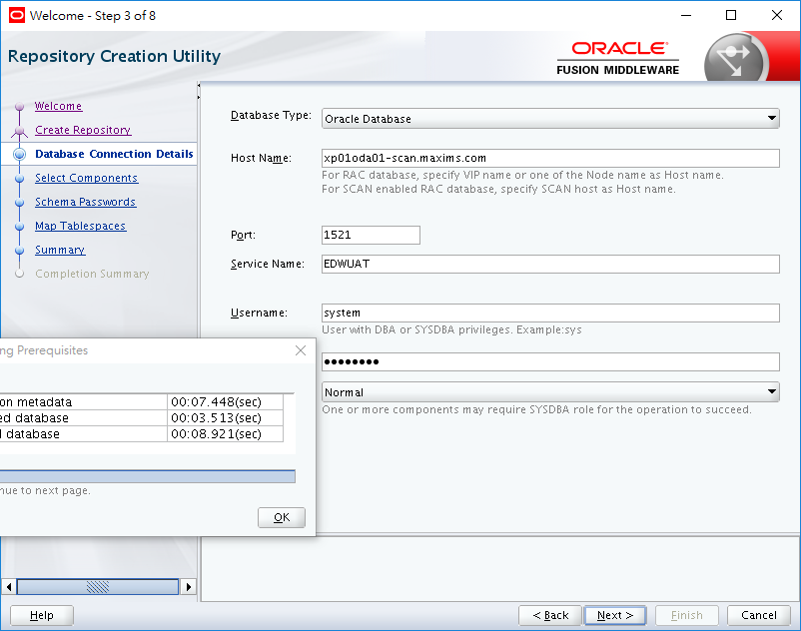

Host: xp01oda01-scan.maxims.com

Port: 1521

Service Name: EDWUAT

Username: system

(Normal)

Check connection Privilege

And SYSDBA role of user.

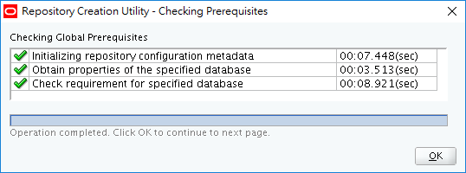

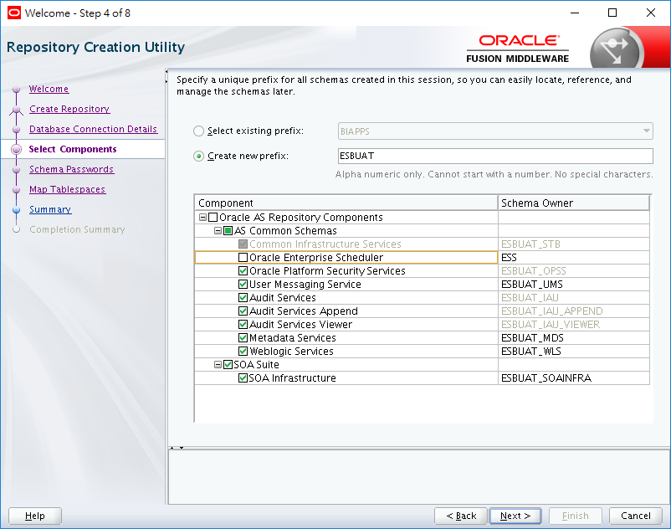

ESBUAT

Select all except ESS

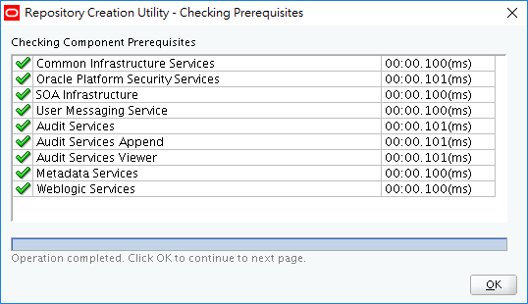

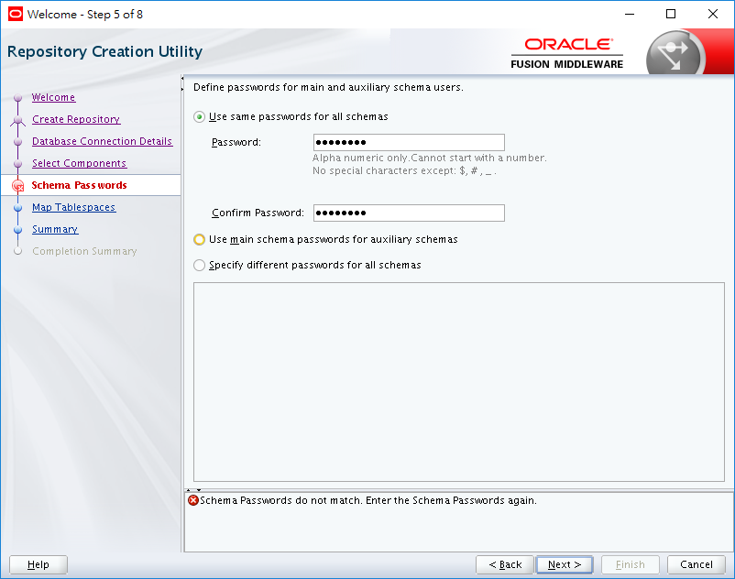

Passw0rd

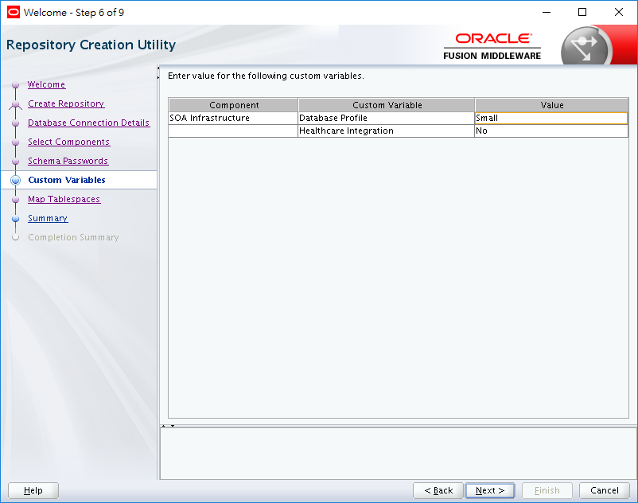

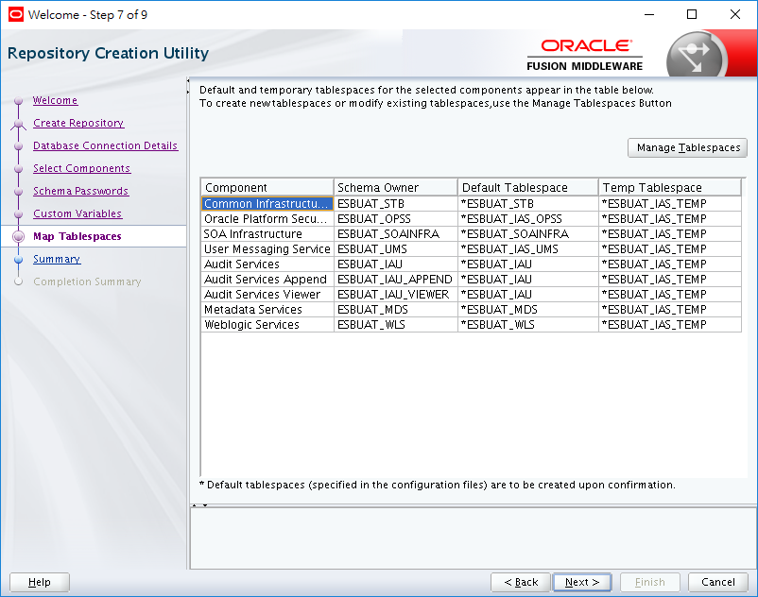

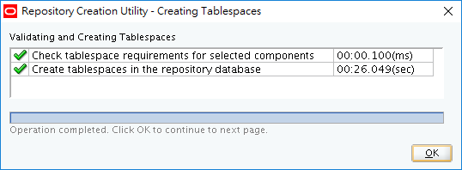

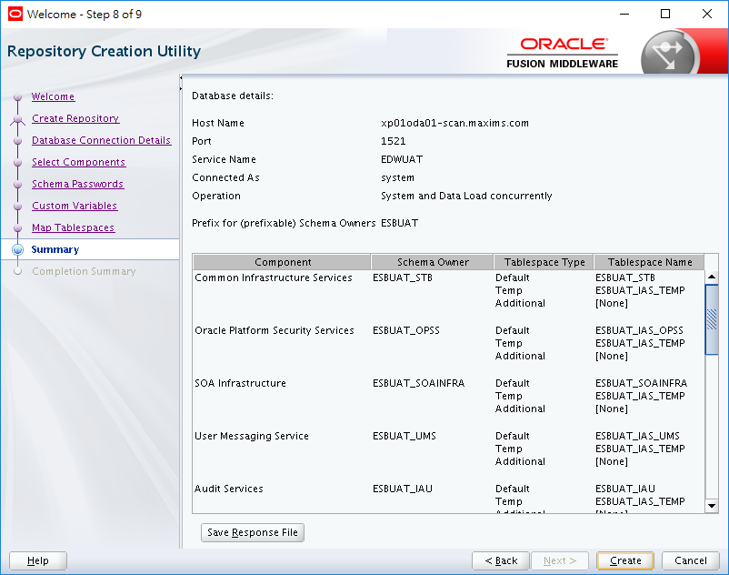

ESB Server (app server)

export DISPLAY=10.20.30.100:0.0

|  |
| --- |
| **Create a Compact Domain**  cd $ORACLE_HOME/oracle_common/common/bin  CONFIG_JVM_ARGS="-Dcom.oracle.cie.config.showProfile=true"  export CONFIG_JVM_ARGS  ./config.sh |



/home/oracle/config/domains/base_domain

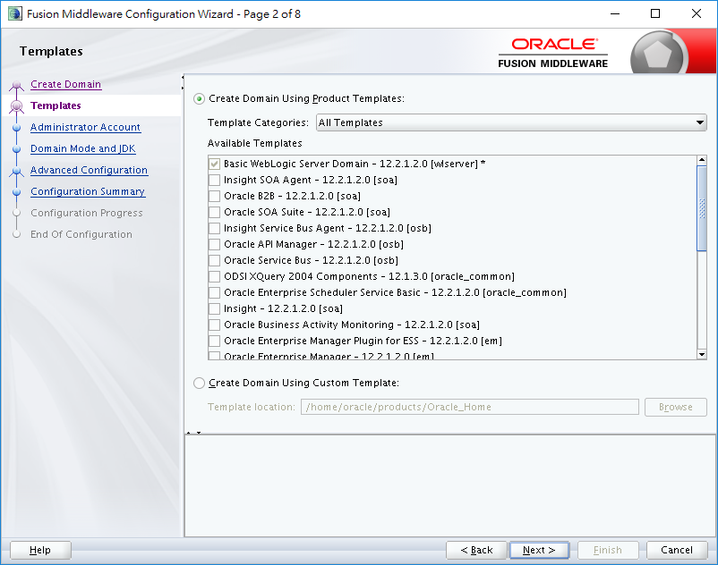

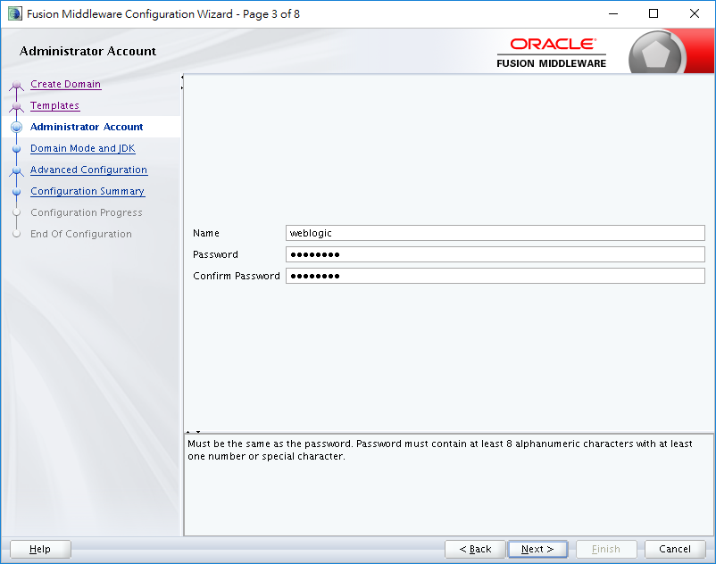

weblogic

Passw0rd

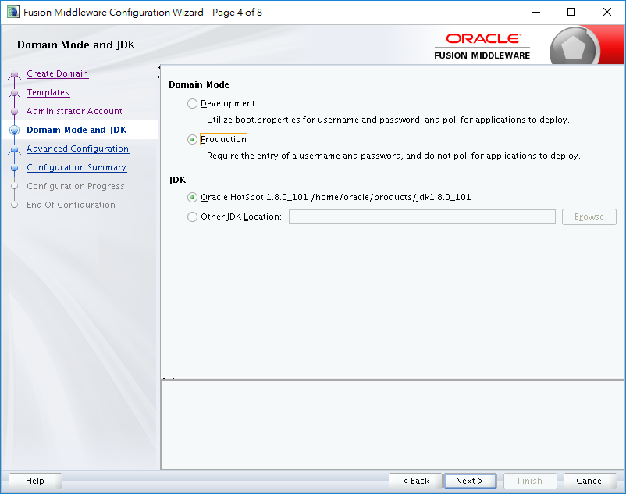

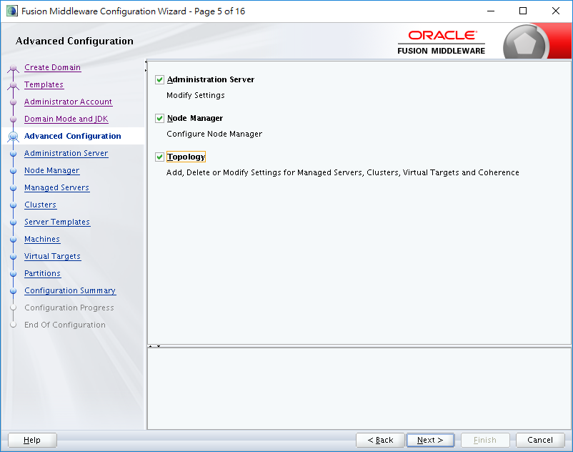

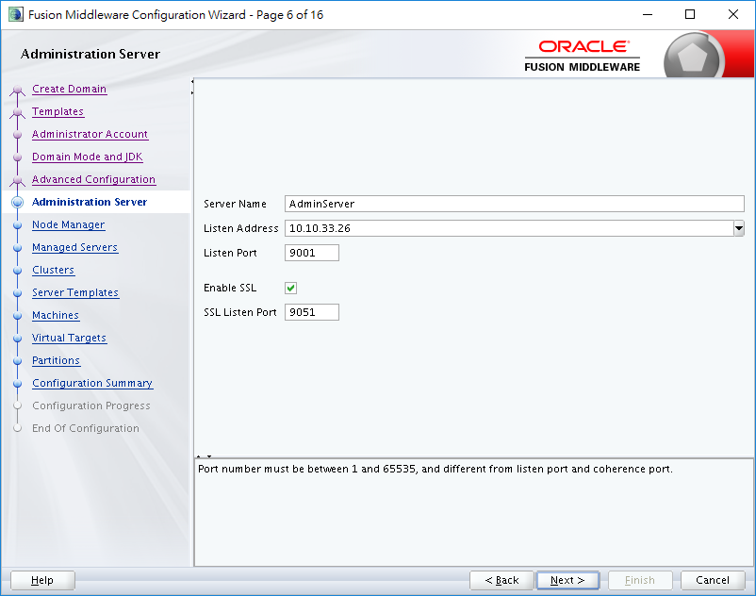

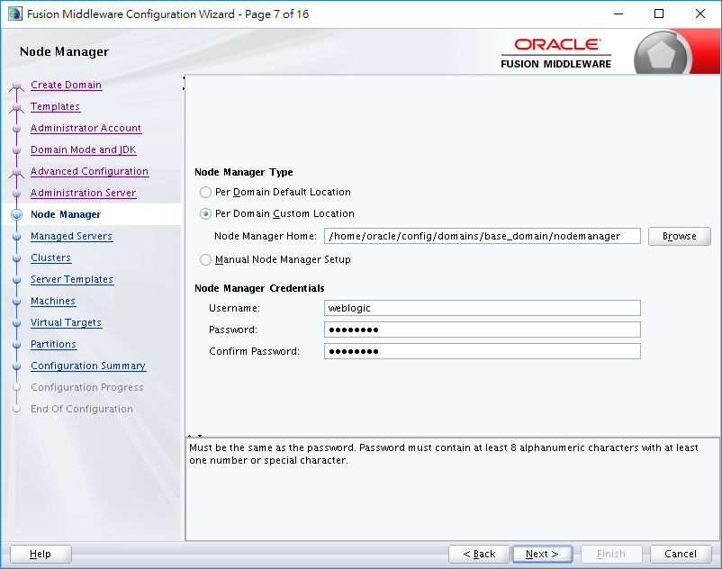

/home/oracle/config/domains/base_domain/nodemanager

Username weblogic

Password: Passw0rd

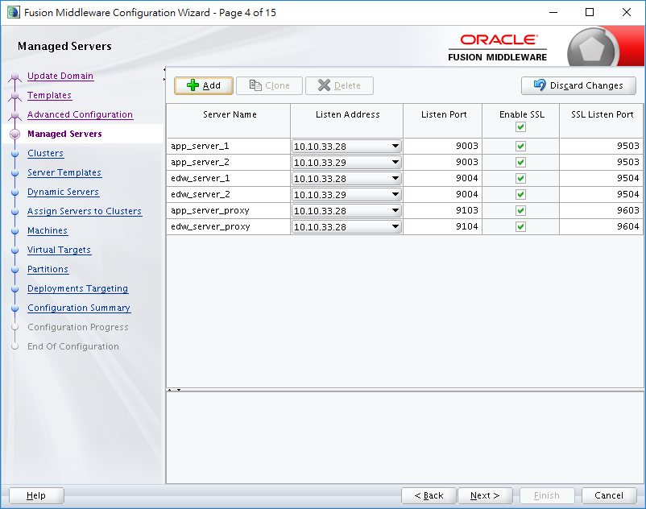

app_server_1 10.10.33.26 9003 9503

app_server_2 10.10.33.27 9003 9503

edw_server_1 10.10.33.26 9004 9504

edw_server_2 10.10.33.27 9004 9504

app_server_proxy 10.10.33.26 9103 9603

edw_server_proxy 10.10.33.26 9104 9604

app_server_1 10.10.33.28 9003 9503

app_server_2 10.10.33.29 9003 9503

edw_server_1 10.10.33.28 9004 9504

edw_server_2 10.10.33.29 9004 9504

app_server_proxy 10.10.33.28 9103 9603

edw_server_proxy 10.10.33.28 9104 9604

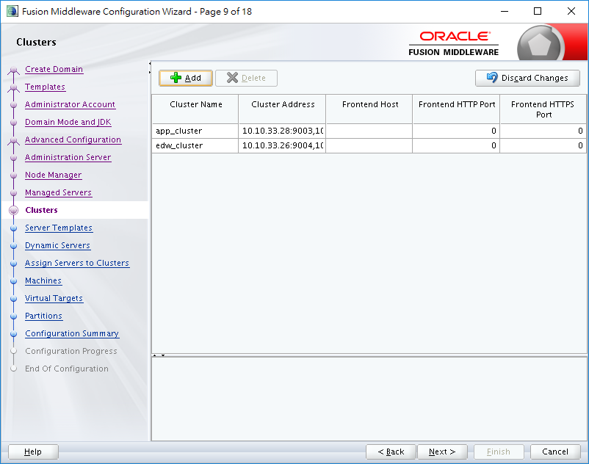

app_cluster 10.10.33.26:9003,10.10.33.27:9003

edw_cluster 10.10.33.26:9004,10.10.33.27:9004

app_cluster 10.10.33.28:9003,10.10.33.29:9003

edw_cluster 10.10.33.28:9004,10.10.33.29:9004

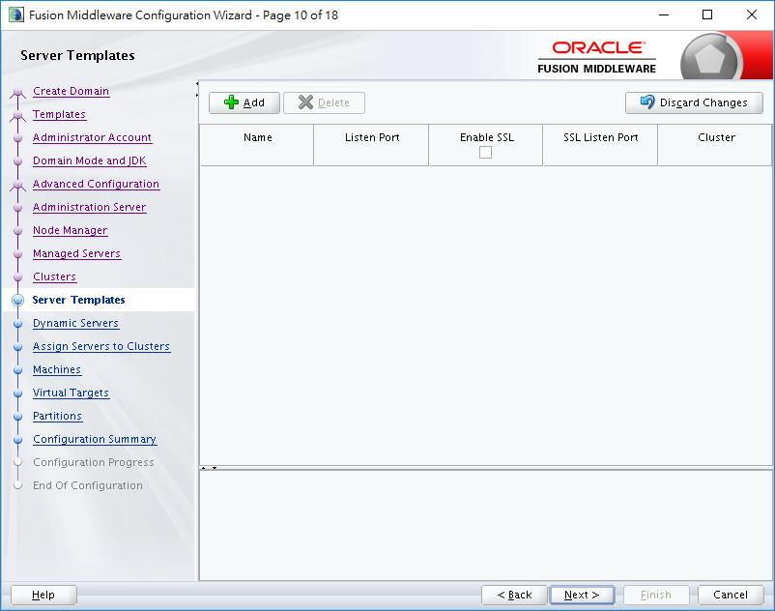

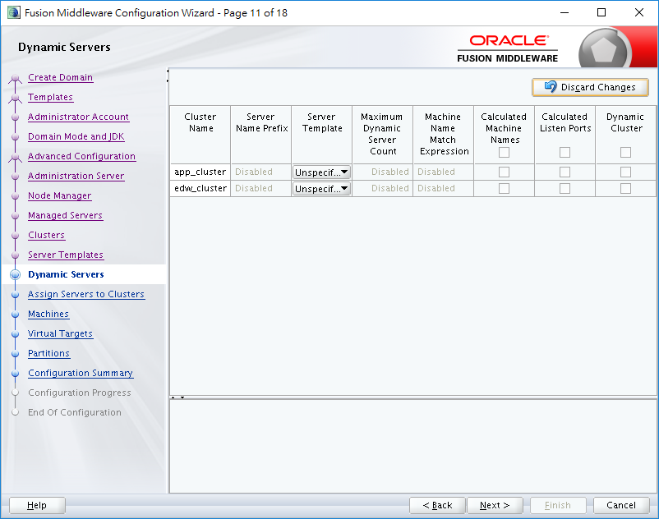

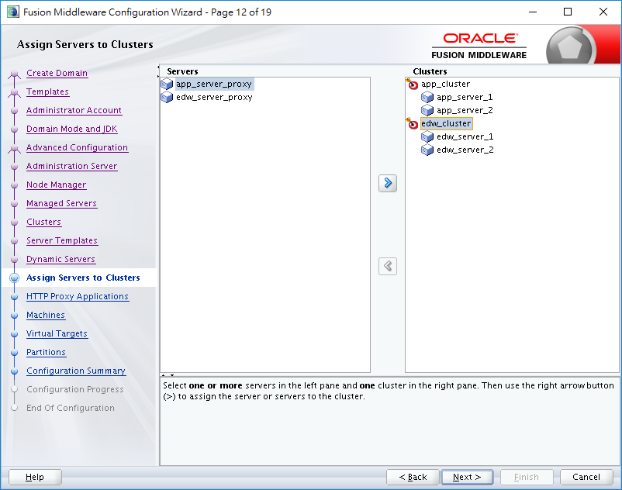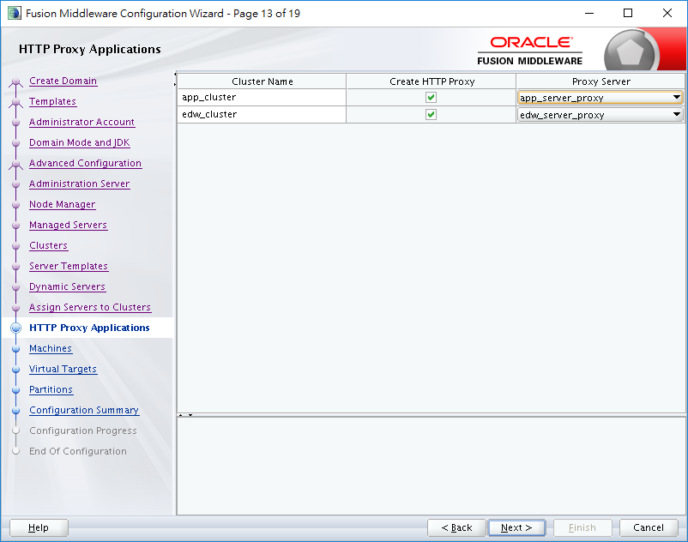

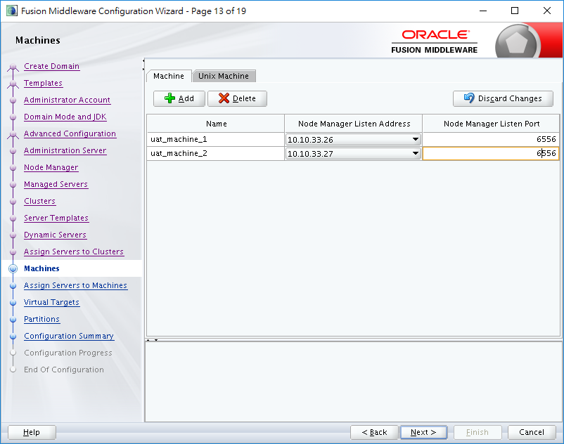

uat_machine_1 10.10.33.26 6556

uat_machine_2 10.10.33.27 6556

prod_machine_1 10.10.33.28 6556

prod_machine_2 10.10.33.29 6556

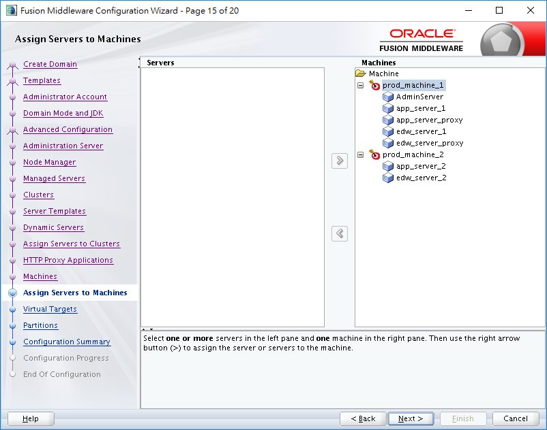

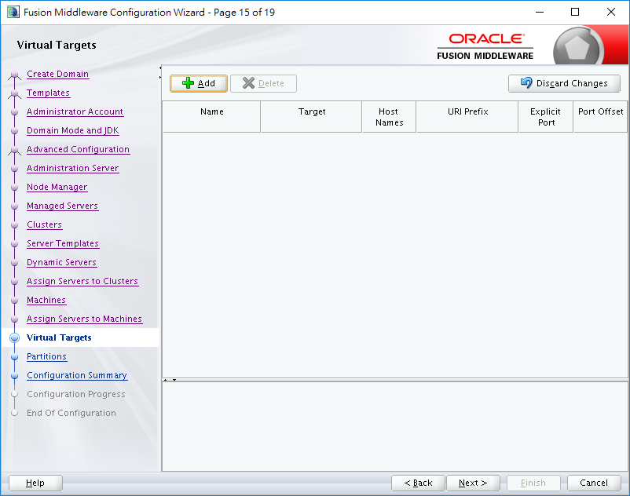

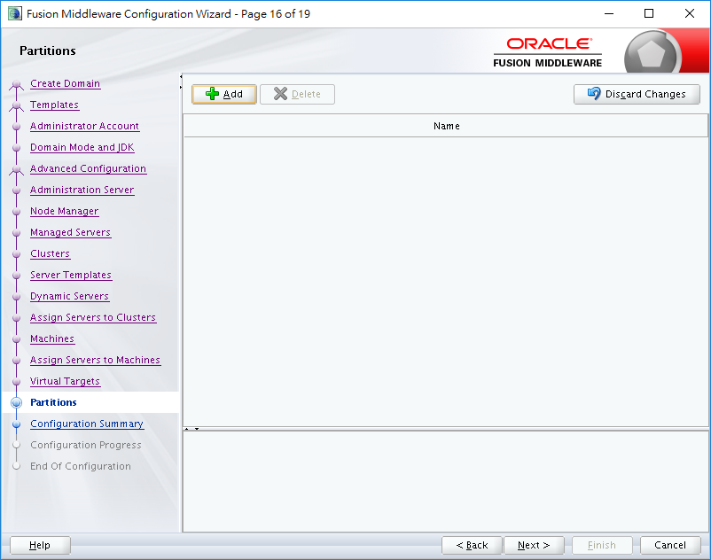

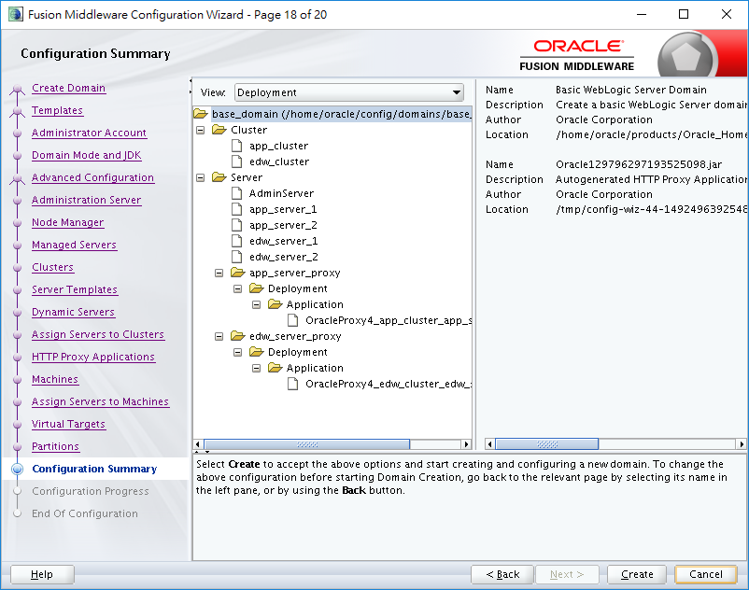

Set Machine 2

cd /home/oracle/products/Oracle_Home/oracle_common/common/bin

./pack.sh -managed=true -domain=/home/oracle/config/domains/base_domain -template=/home/oracle/base_domain.jar -template_name="base_domain"

Upload the jar to machine 2

"c:\progra~1\putty\psftp" oracle@10.10.33.26 -pw Passw0rd

cd /home/oracle

get base_domain.jar

"c:\progra~1\putty\psftp" oracle@10.10.33.27 -pw Passw0rd

cd /home/oracle

put base_domain.jar

machine2

cd /home/oracle/products/Oracle_Home/oracle_common/common/bin

./unpack.sh -domain=/home/oracle/config/domains/base_domain -template=/home/oracle/base_domain.jar

cd "/home/oracle/config/domains/base_domain"

nohup bin/startNodeManager.sh > nodemanager/nodemanager.out 2>&1 &

nohup bin/startWebLogic.sh -Dweblogic.management.username=weblogic -Dweblogic.management.password=Passw0rd -Dweblogic.system.StoreBootIdentity=true > admin.out&

nohup bin/startNodeManager.sh > nodemanager/nodemanager.out 2>&1 &

WLS_REDIRECT_LOG=”/home/oracle/config/domains/base_domain

mput *.sh

cd "/home/oracle/config/domains/standalone_domain/servers/AdminServer"

cd "/home/oracle/config/domains/base_domain/servers/AdminServer"

mkdir security

cd security

create boot.properties

password=Passw0rd

username=weblogic

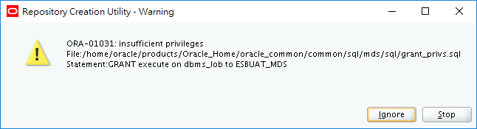

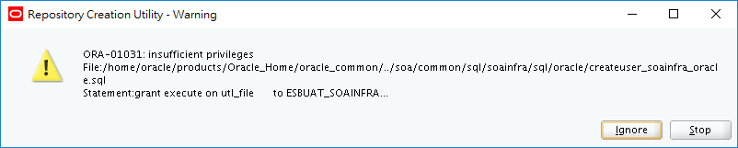

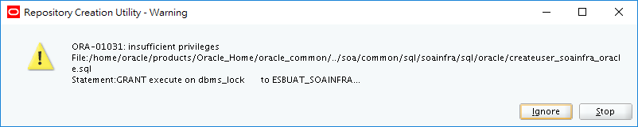

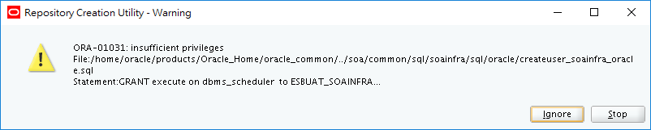

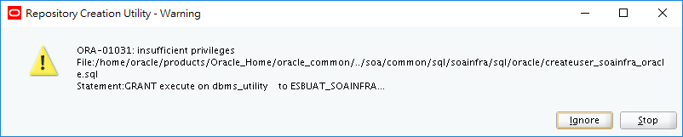

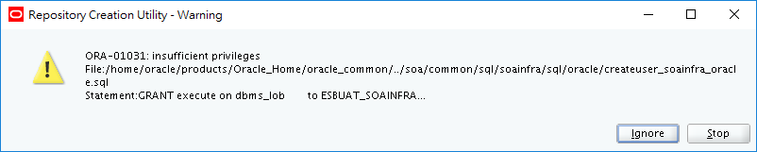

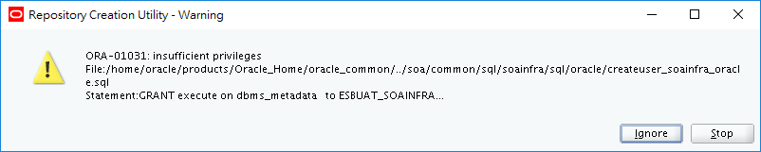

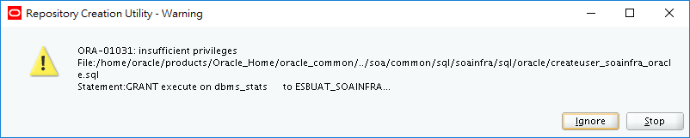

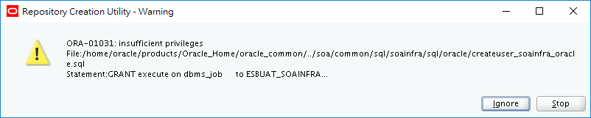

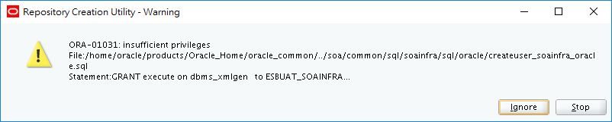

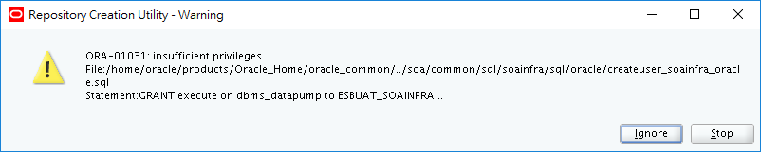

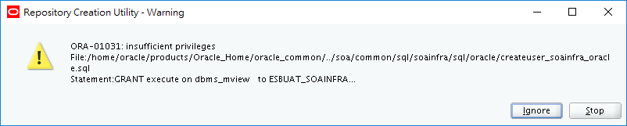

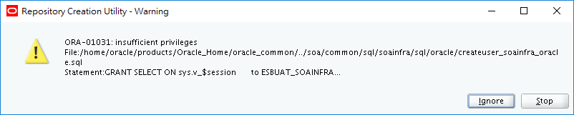

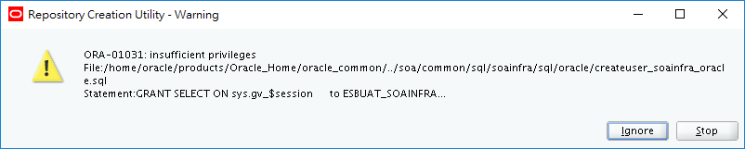

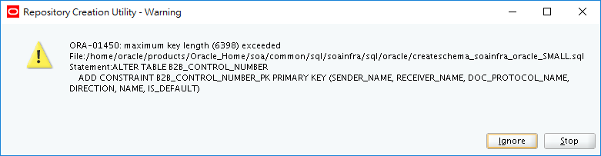

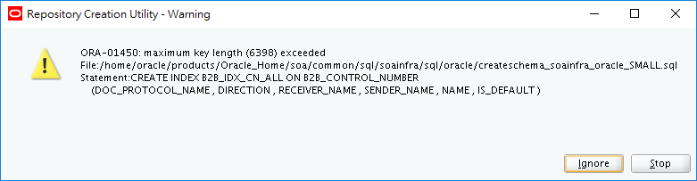

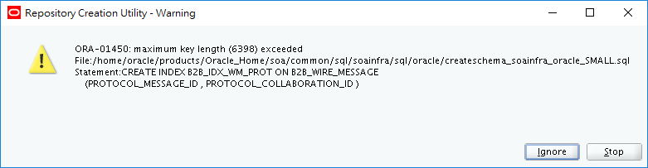

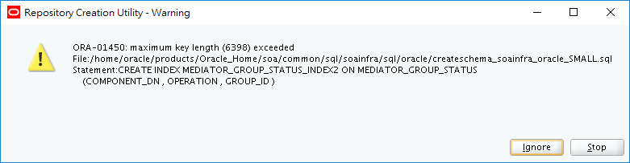

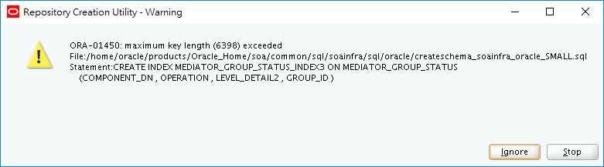

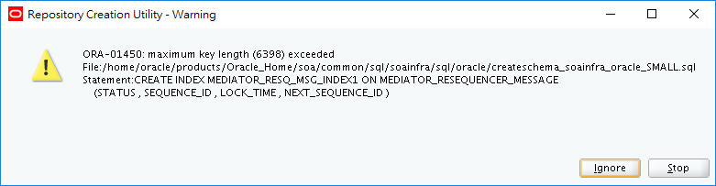

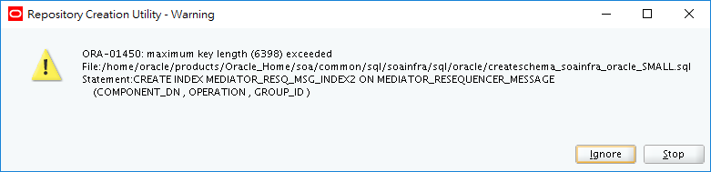

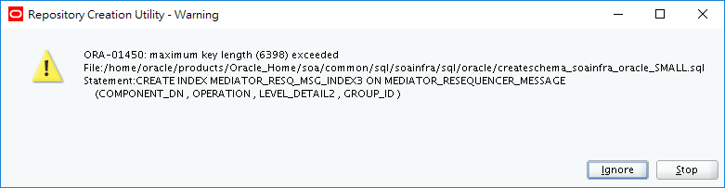

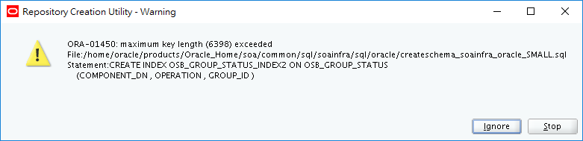

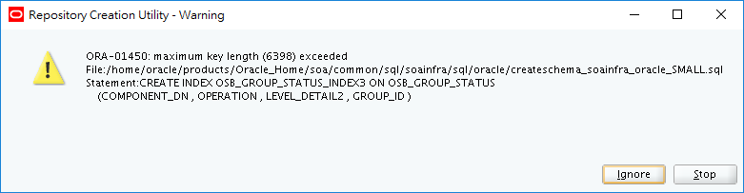

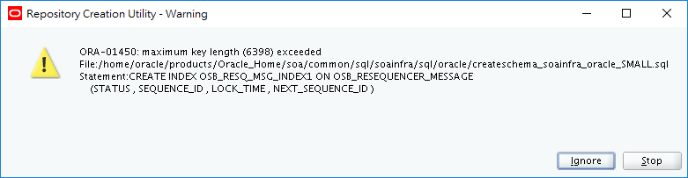

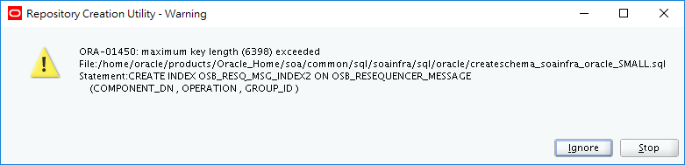

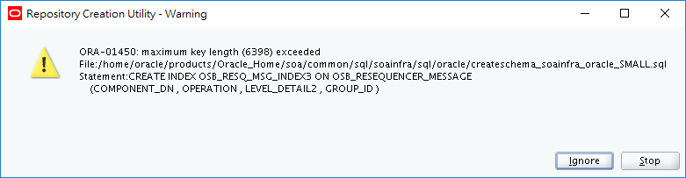

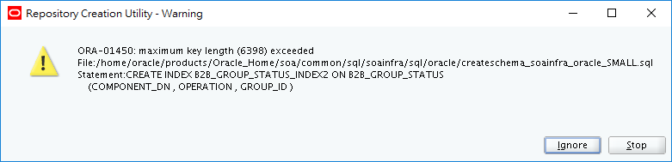

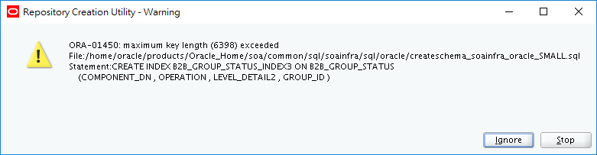

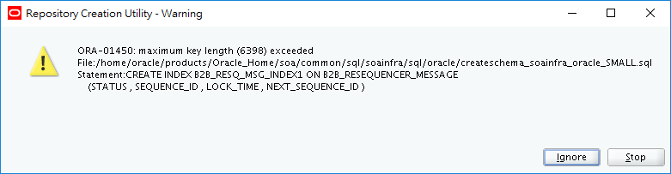

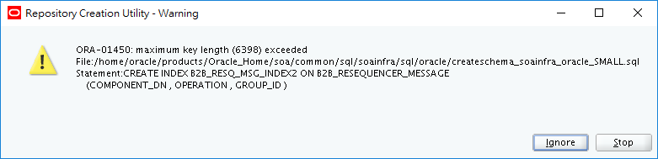

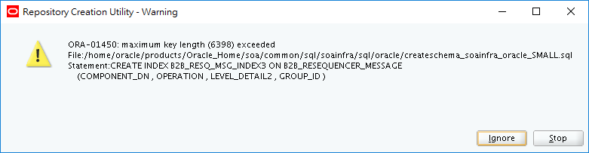

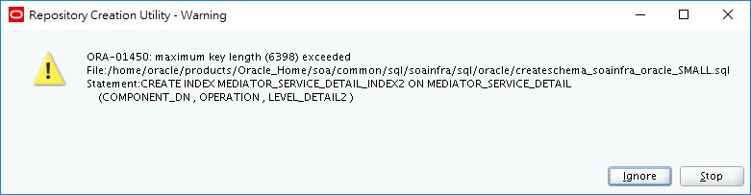

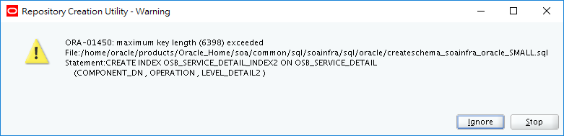

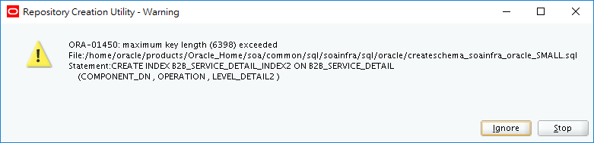

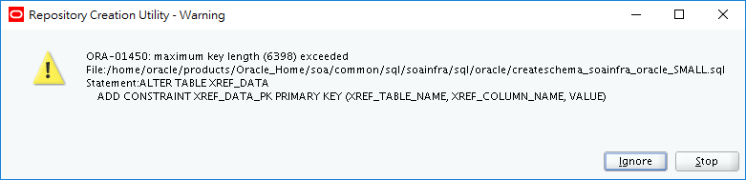

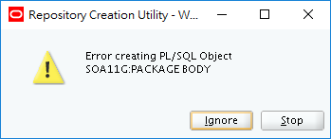

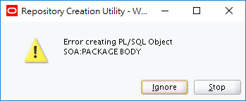

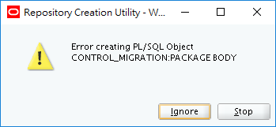

This release of Oracle Fusion Middleware only supports schemas in a byte-mode database. The NLS_LENGTH_SEMANTICS initialization parameter, on the database where the schemas reside, must be set to BYTE; setting this parameter to CHAR is not supported.

If NLS_LENGTH_SEMANTICS is set to CHAR, then the Upgrade Assistant will report the following exception:

JDBC SQLException - ErrorCode: 1450SQLState:72000 Message: ORA-01450: maximum key length (6398) exceeded

To check the values of this parameter using SQL*Plus, you can use the show parameters command:

prompt> sqlplus "sys/<password> as sysdba"SQL> show parameters nls_length_semantics

Replace *<password>* with the actual password for the SYS user.

Alternatively,

you can check the values by querying the V$PARAMETER view:

prompt> sqlplus "sys/password as sysdba"SQL> select name,value from v$parameter;

Issue 2

